SETUP (PROJECT ENVIRONMENT & SPHINX)

1. Open visual studio

2. Navigate to empty project directory (cd Documents/GIT/QIB-Sheffield/project_name)

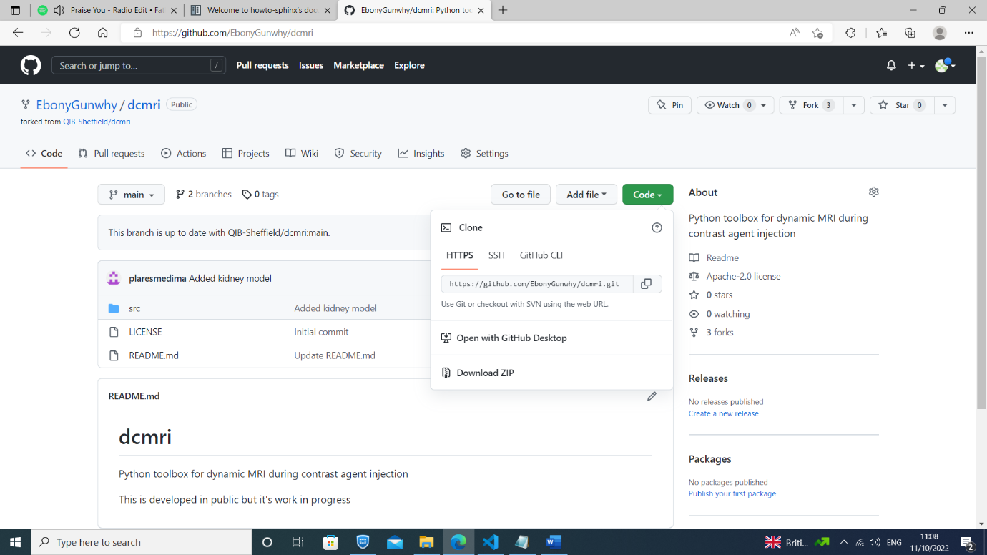3. Clone project from github (git clone -b branch_name https://github.com/account_name/project_name.git .)

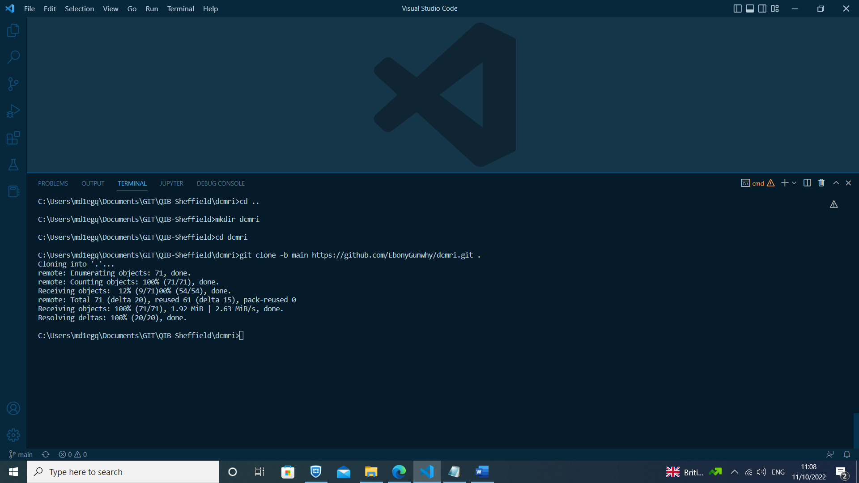

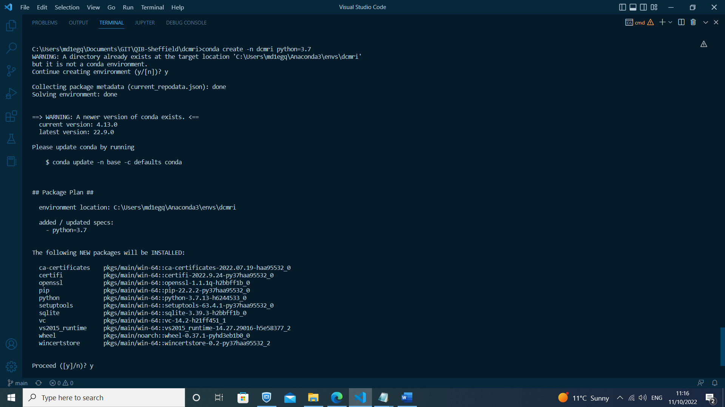4. Create virtual environment (conda create --name project_name python=3.7)

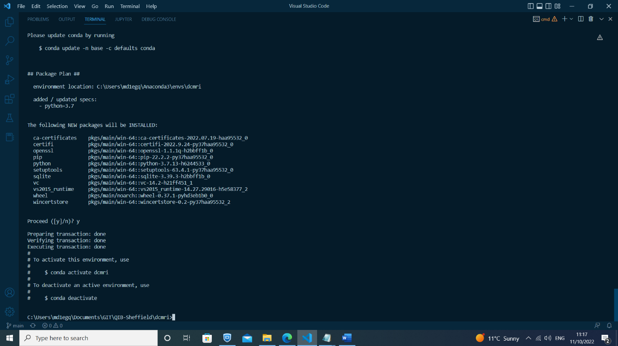

5. Activate virtual environment (conda activate project_name)

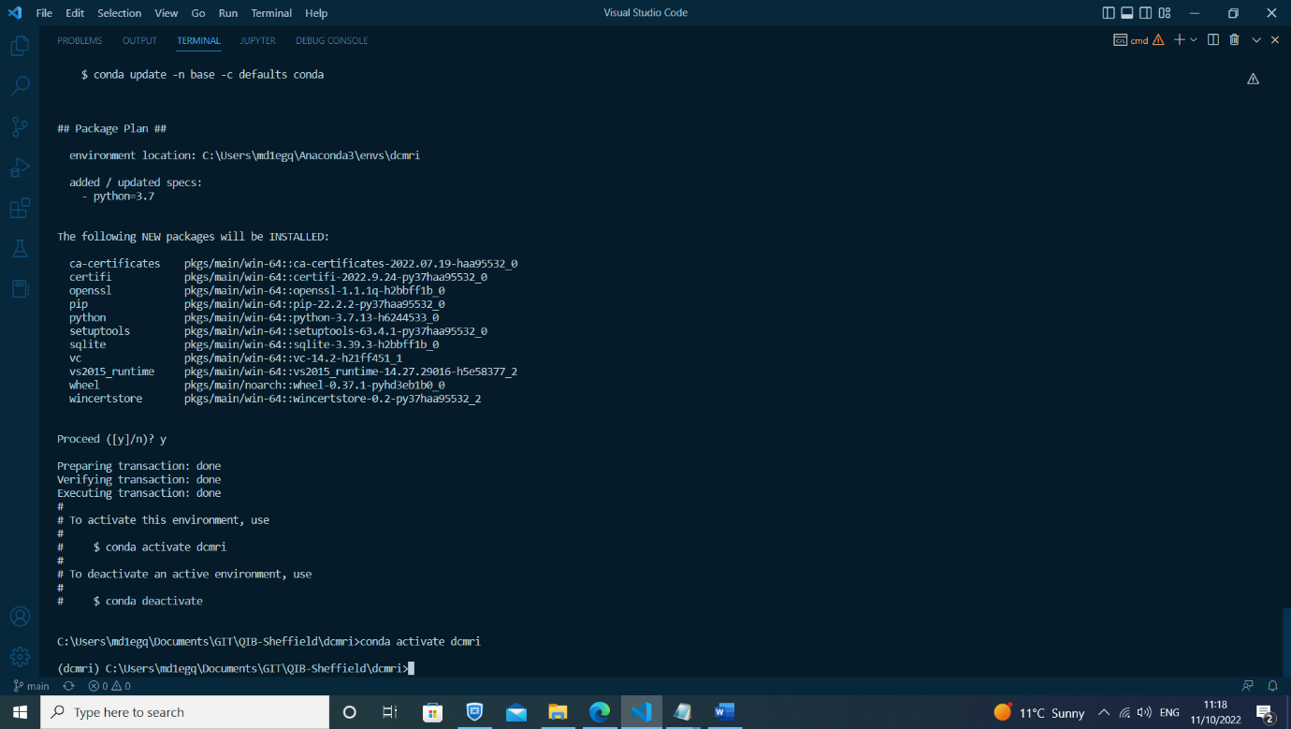

6. Create requirements.txt file with list of required packages to install, e.g.,:

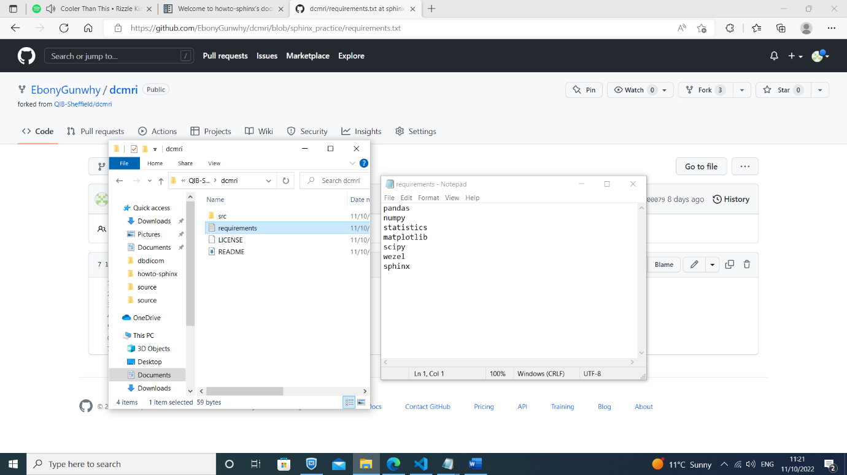

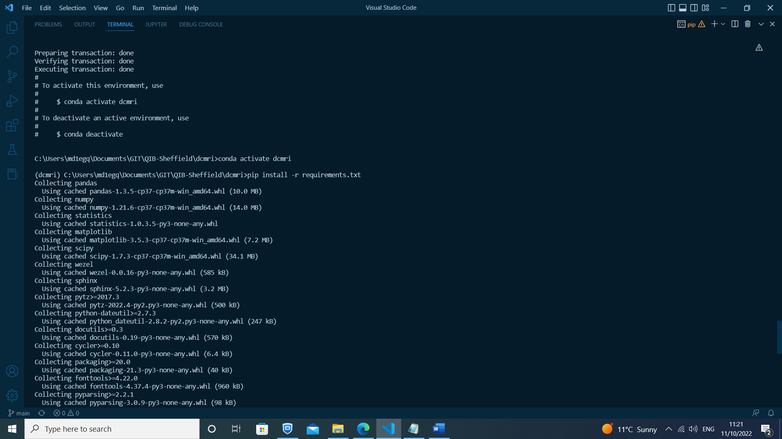7. Install required packages (pip install -r requirements.txt)

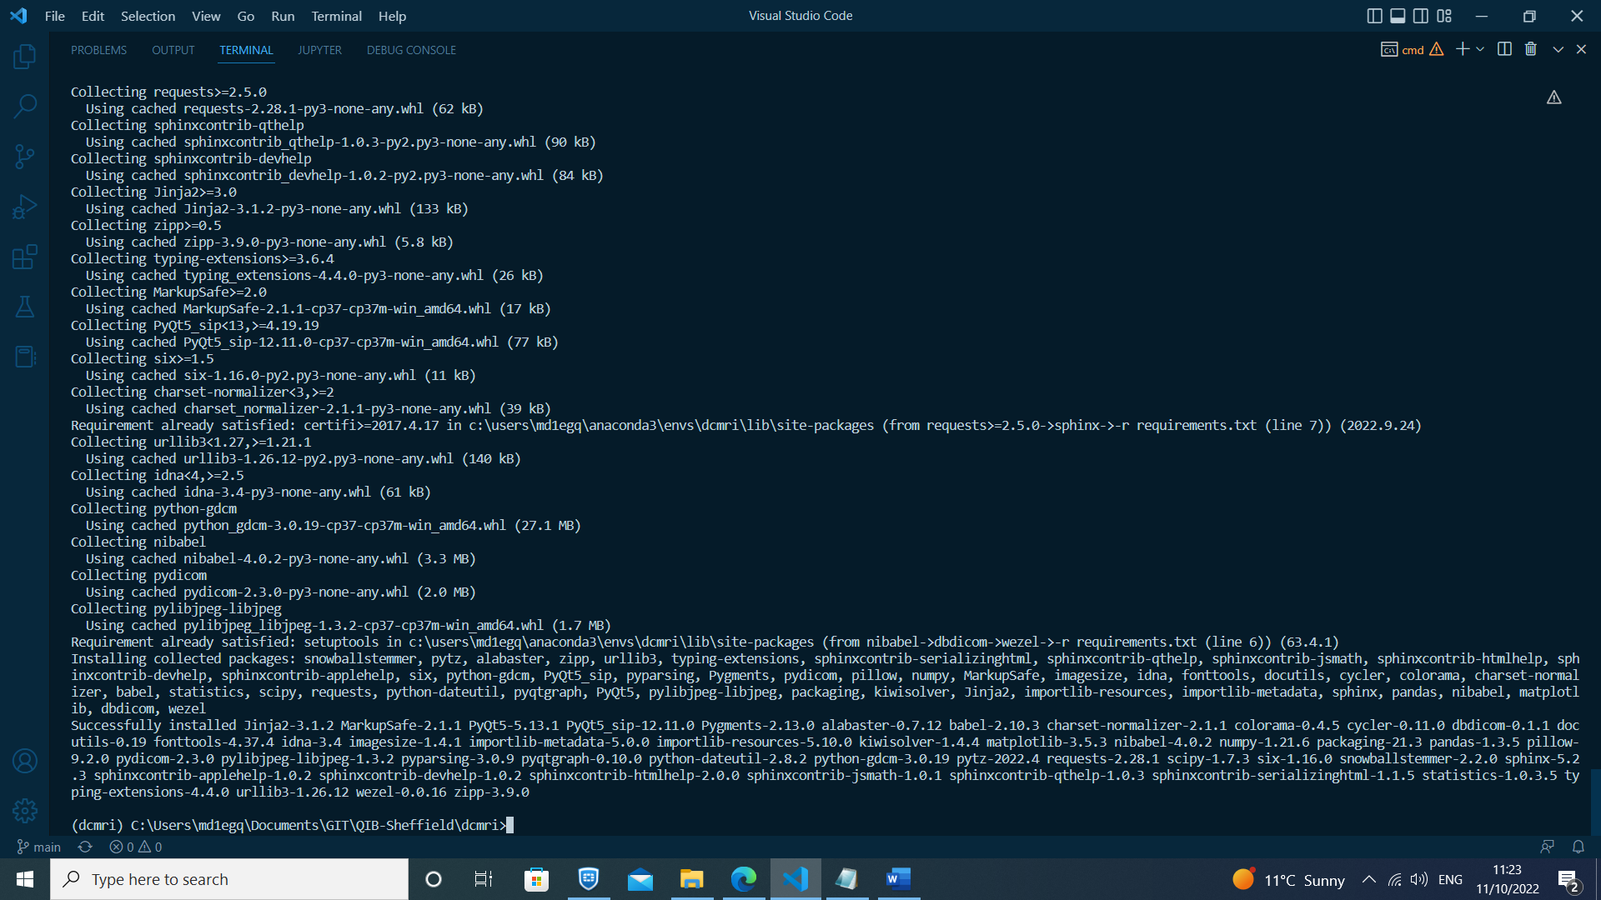

8. Create documentation folder (mkdir docs)

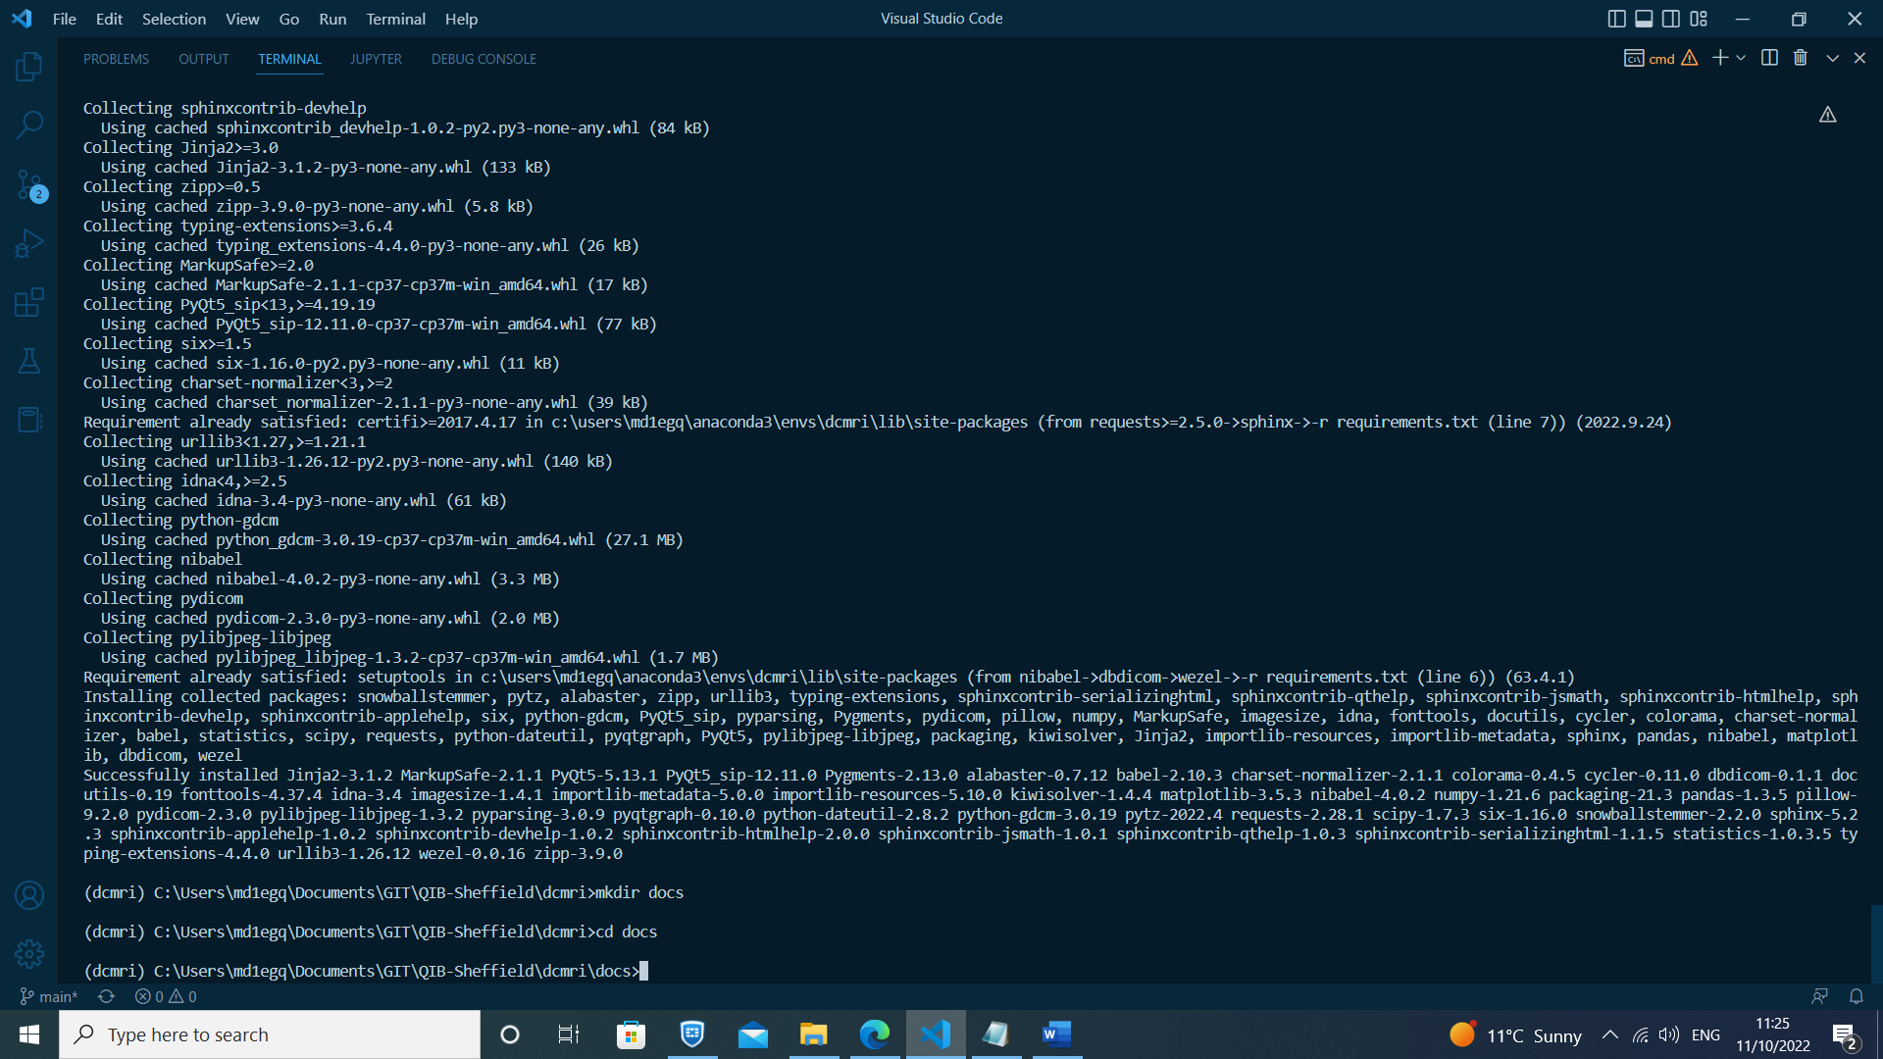9. Navigate to documentation folder (cd docs)

10. Run Sphinx quickstart (sphinx-quickstart)

i. Separate source and build directories (y)

ii. Project name (project_name)

iii. Author name (QIB-Sheffield)

iv. Project release/version (1.0)

v. Project language (en)

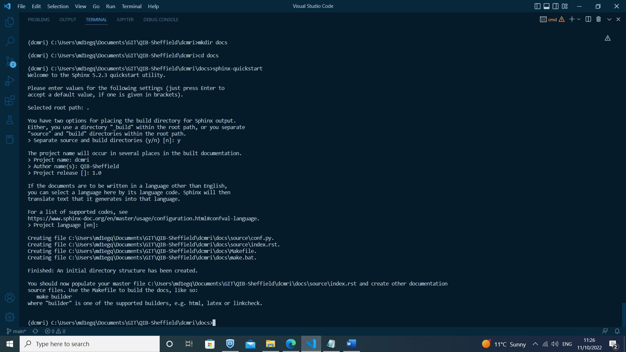

++++++++++++++++++++++++++++++++++++++++++++++++++++++++++++++++++++++++++++++++++

COMMIT #1 "Initial Sphinx documentation build"

- Run basic build without modifying index.rst/conf.py files (sphinx-quickstart, make html)

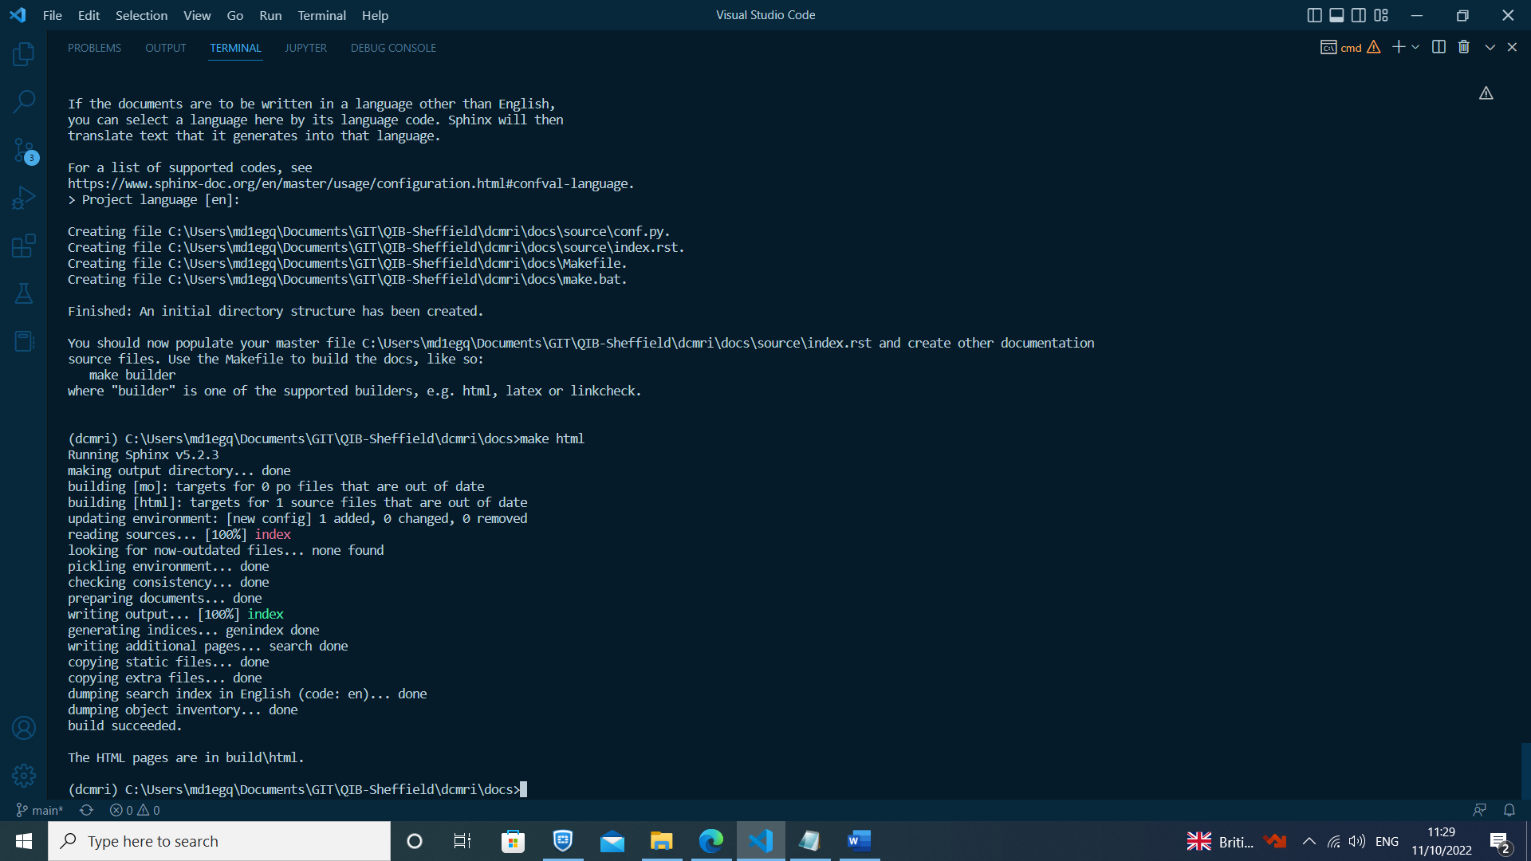

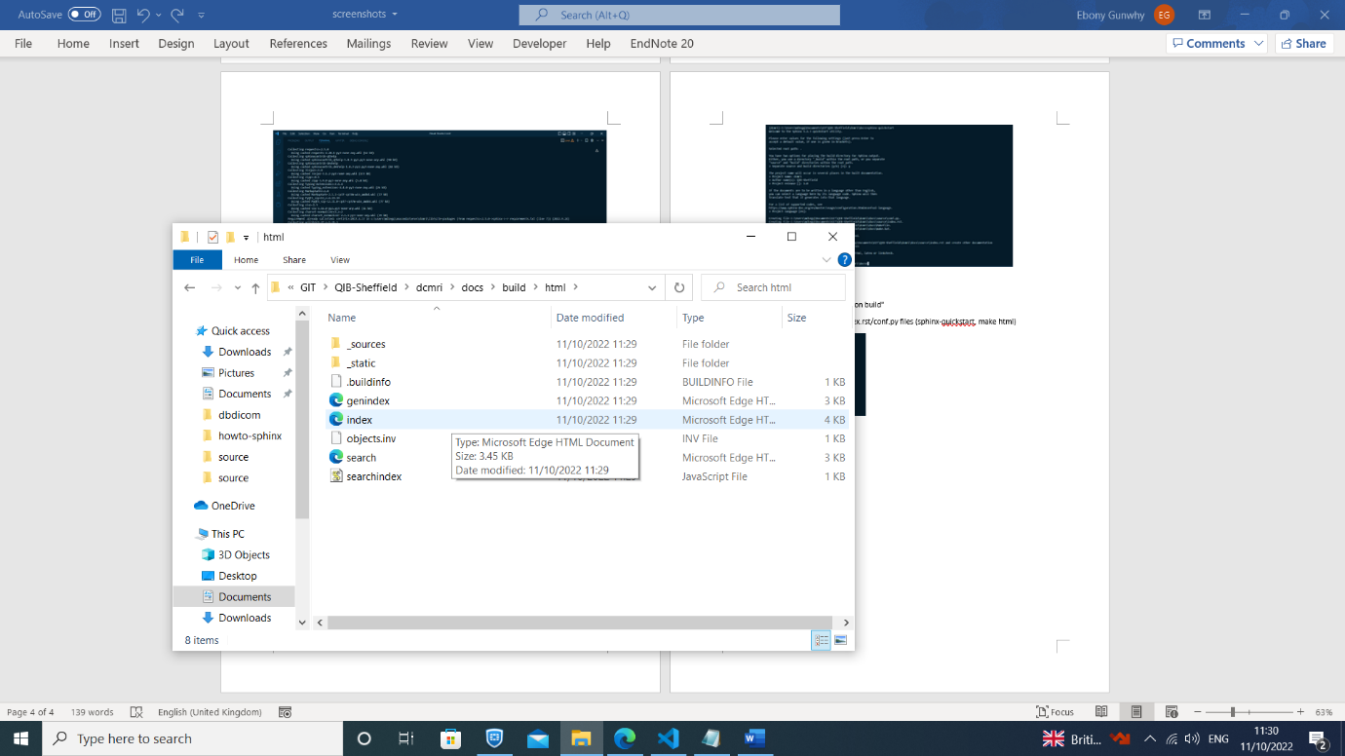- Check sphinx build

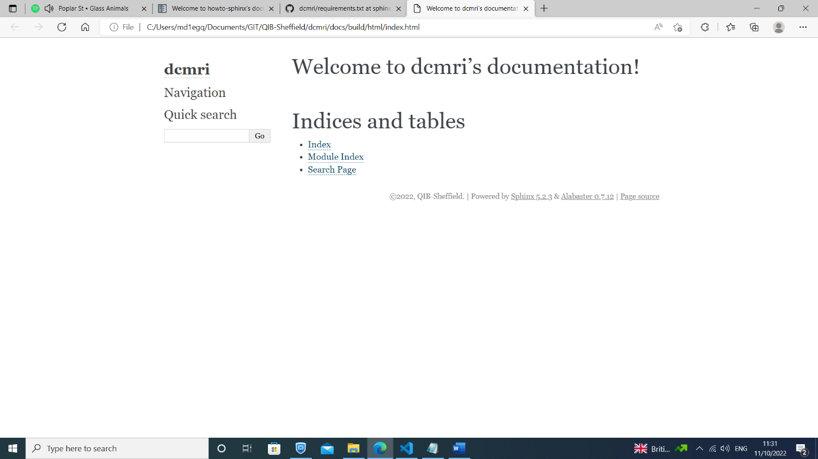

DEPLOY ONLINE (GITHUB & READTHEDOCS)

- Push to Github

A. PUSHING TO GITHUB BRANCH

-----------------------------------------------------------------------------------------------------------

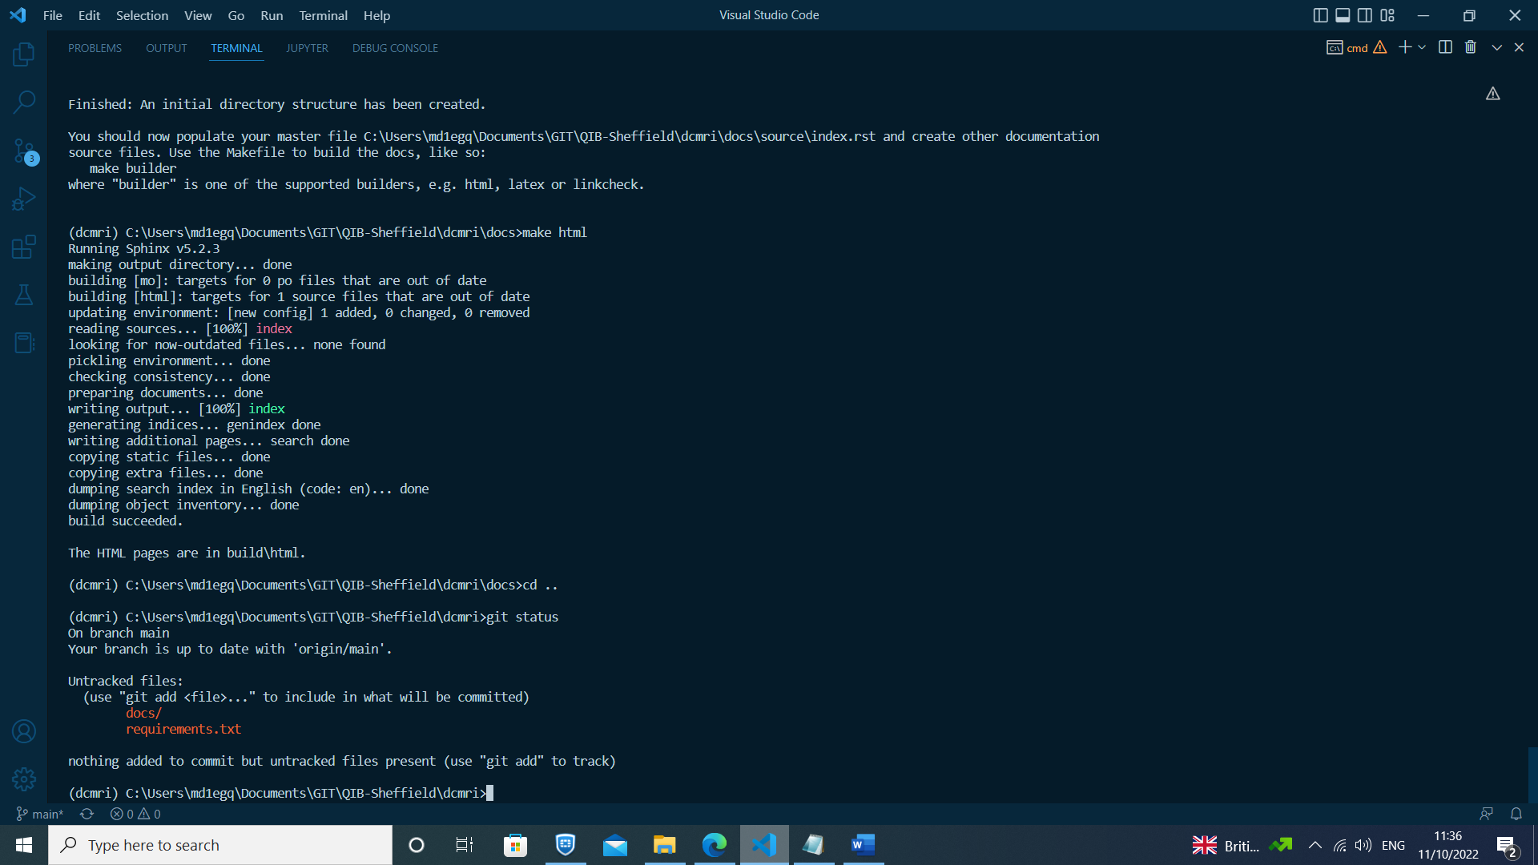1. Check status of ignored/uncommited (untracked) files (git status)

2. Add/edit .gitignore file to include files/folders which should not be pushed to github repository:

src/__pycache__/

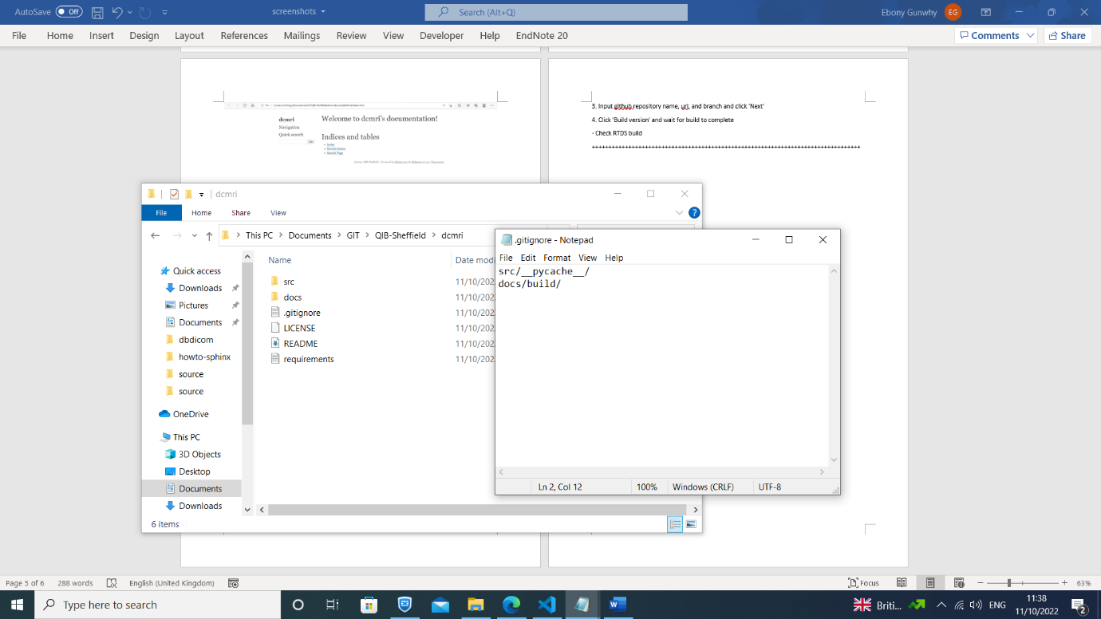 docs/build/

3. Create a branch for committing files to (git checkout -b branch_name)

4. Add files to github staging area (git add -A)

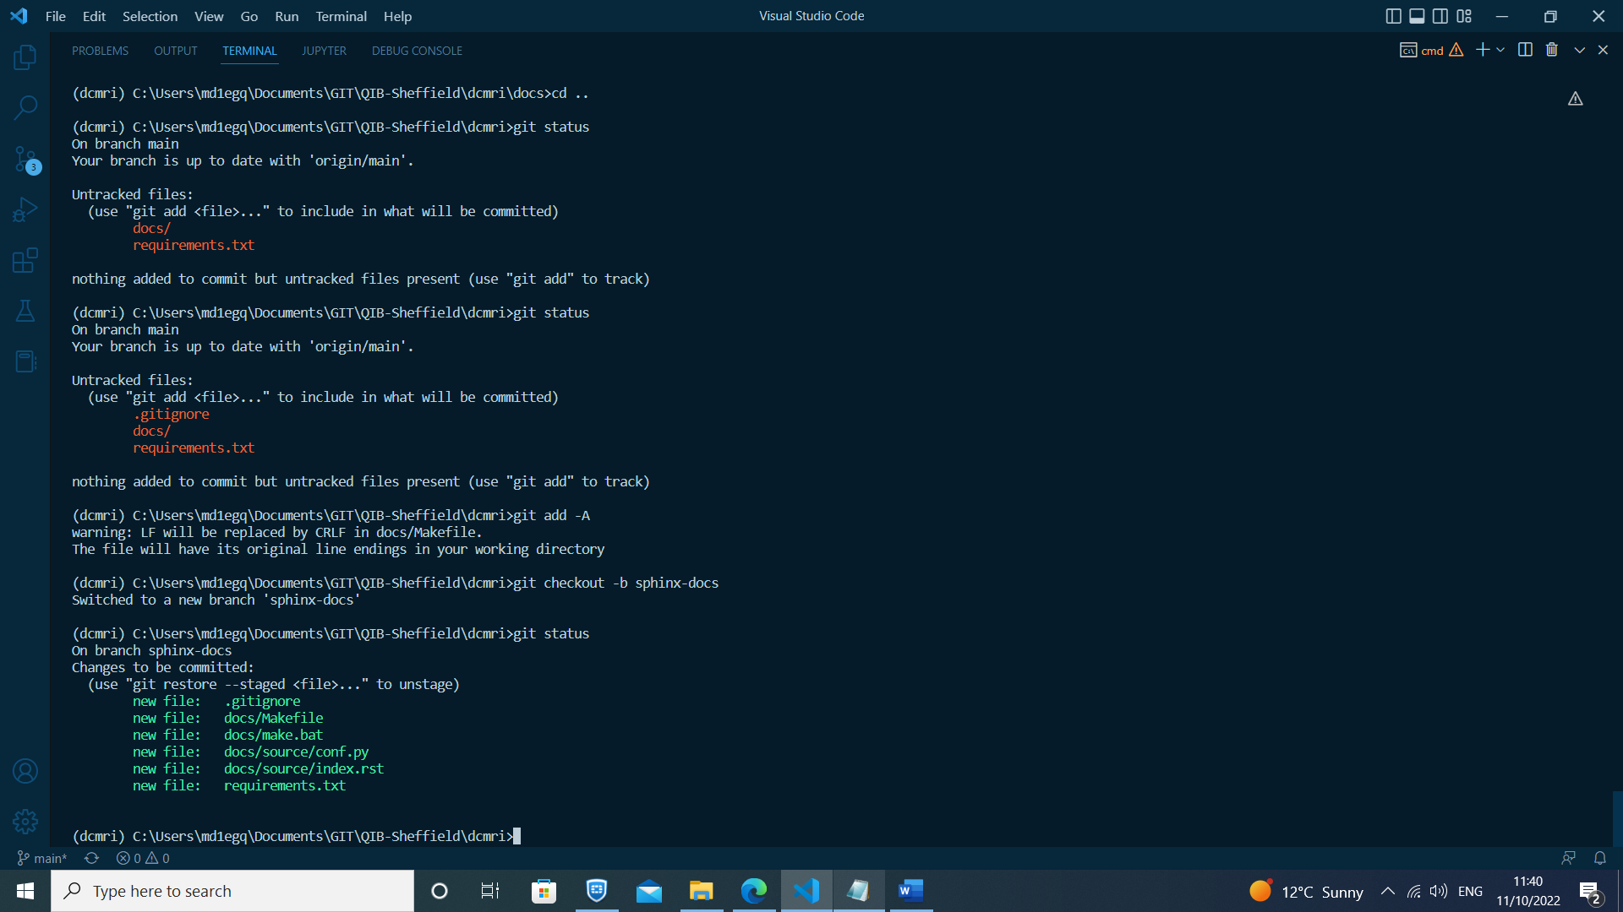

5. Commit staged files to github (git commit -m"First commit")

6. Push commited files to online github repository (git push origin branch_name)

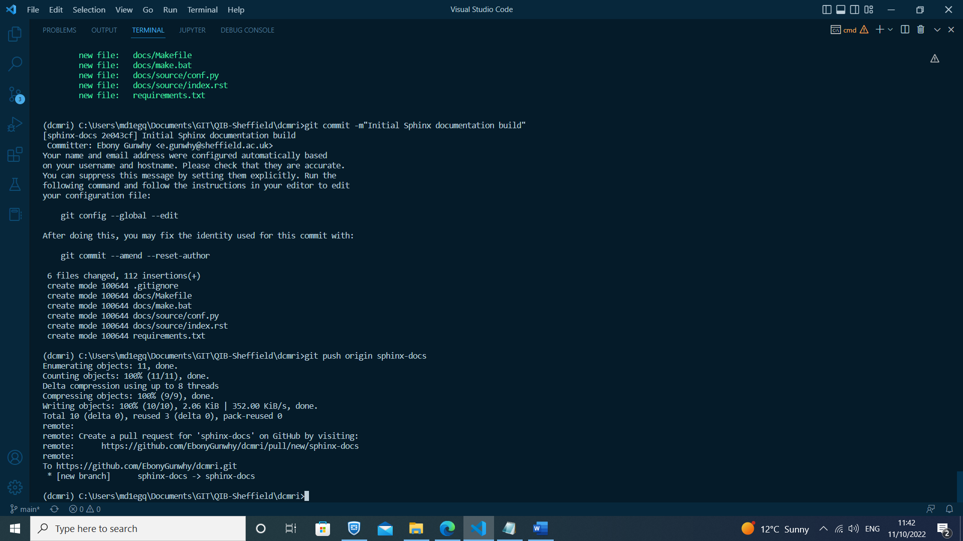

- Sync with RTDs

B. SYNCING TO READTHEDOCS

-----------------------------------------------------------------------------------------------------------

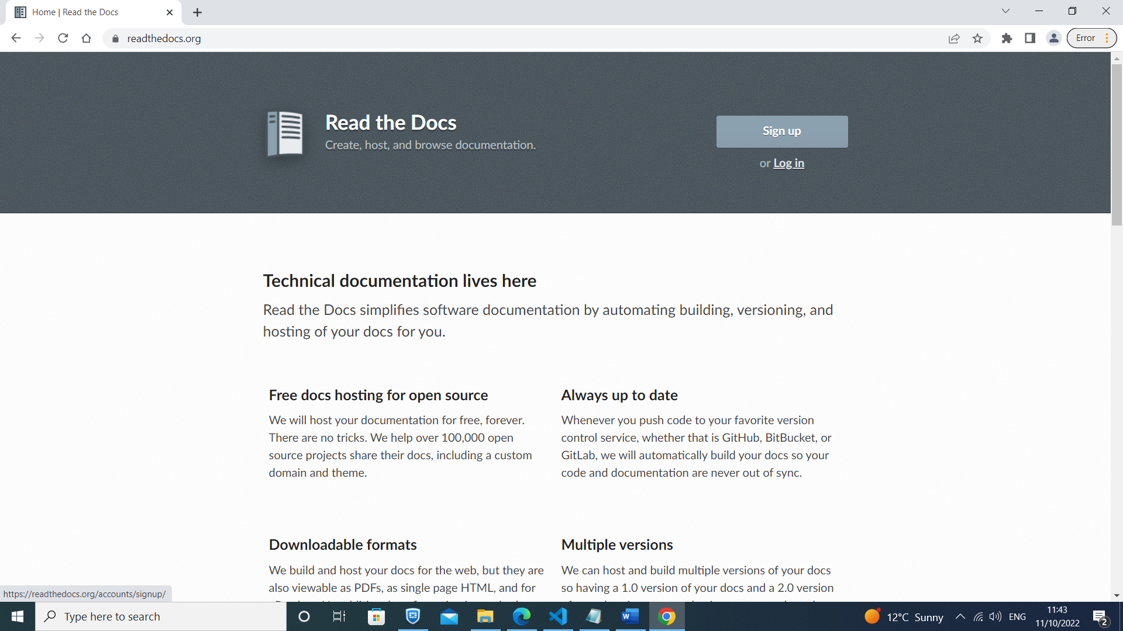1. Create an account (option to link to github account) on readthedocs.org

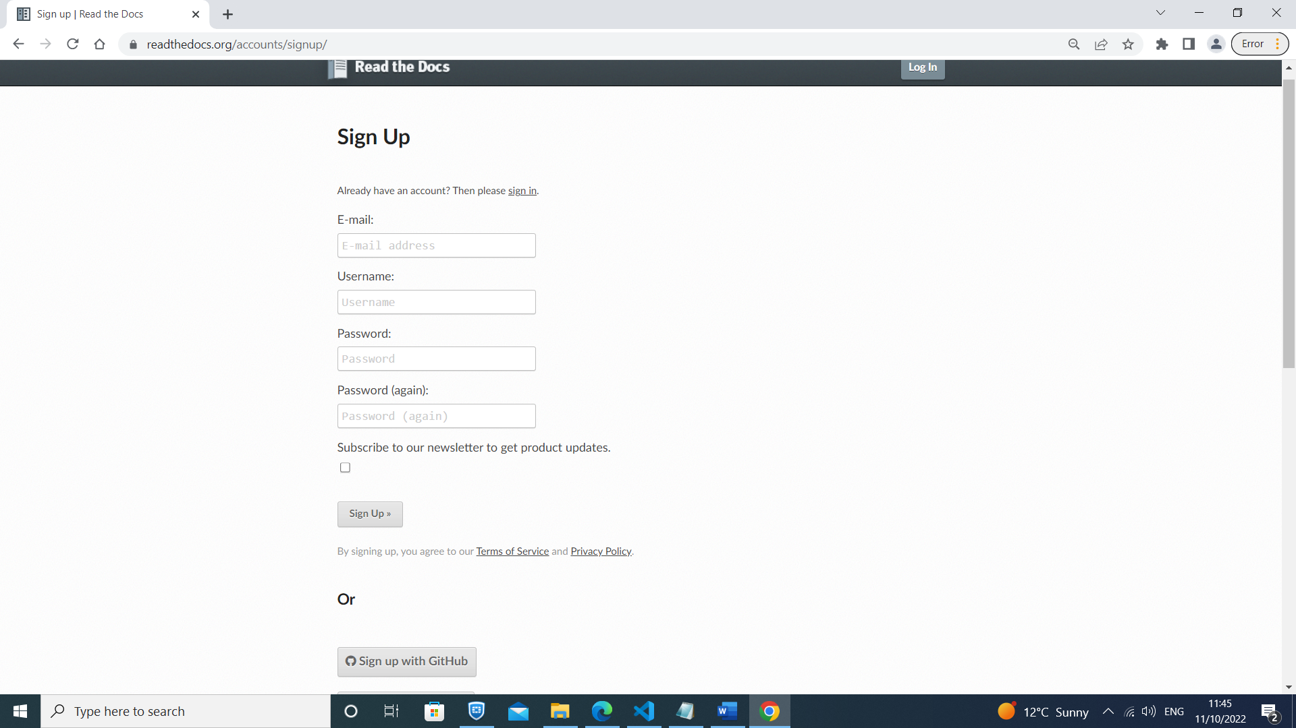

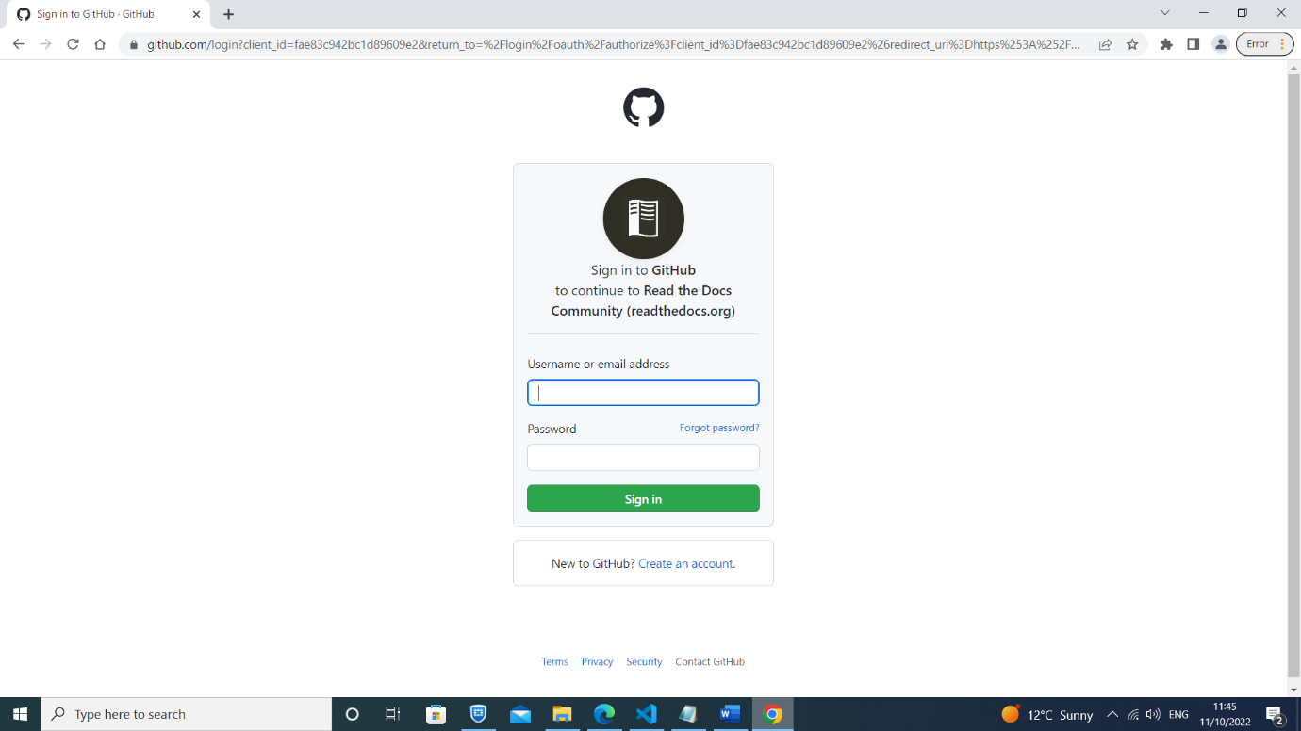

2. At top right of page click on drop down box next to account name and go to:

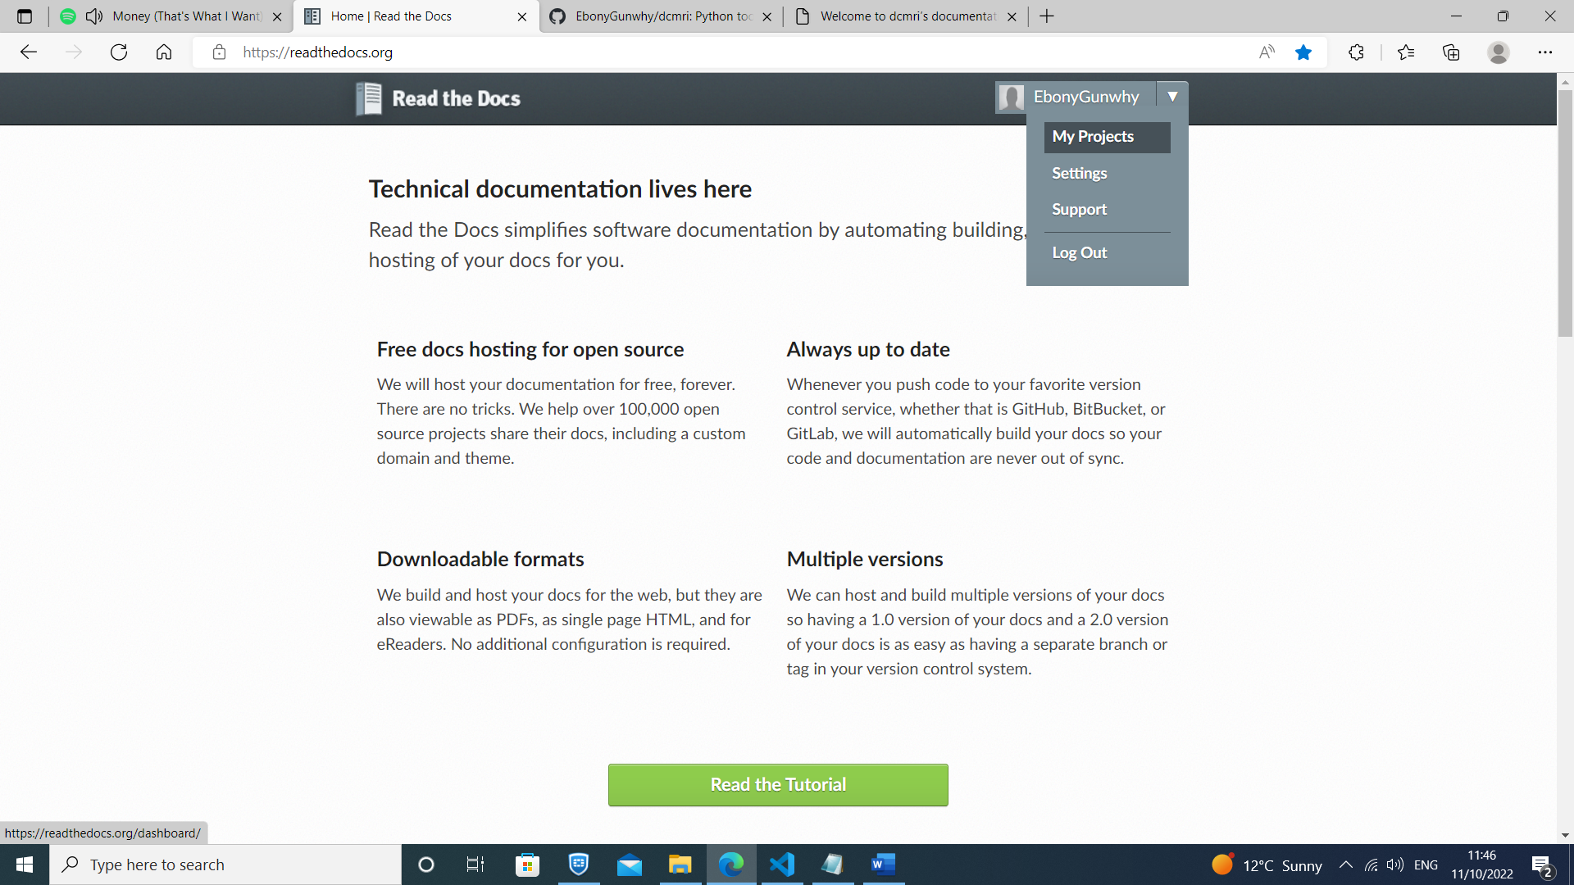 'My Projects -> Import a Project -> Import manually'

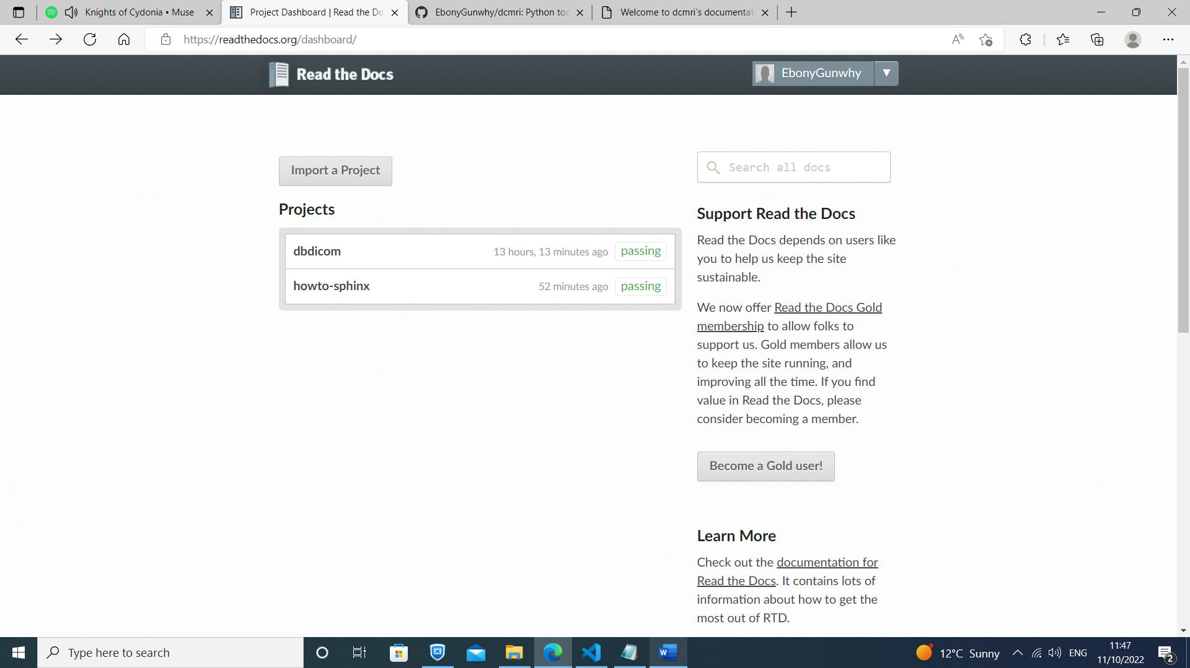

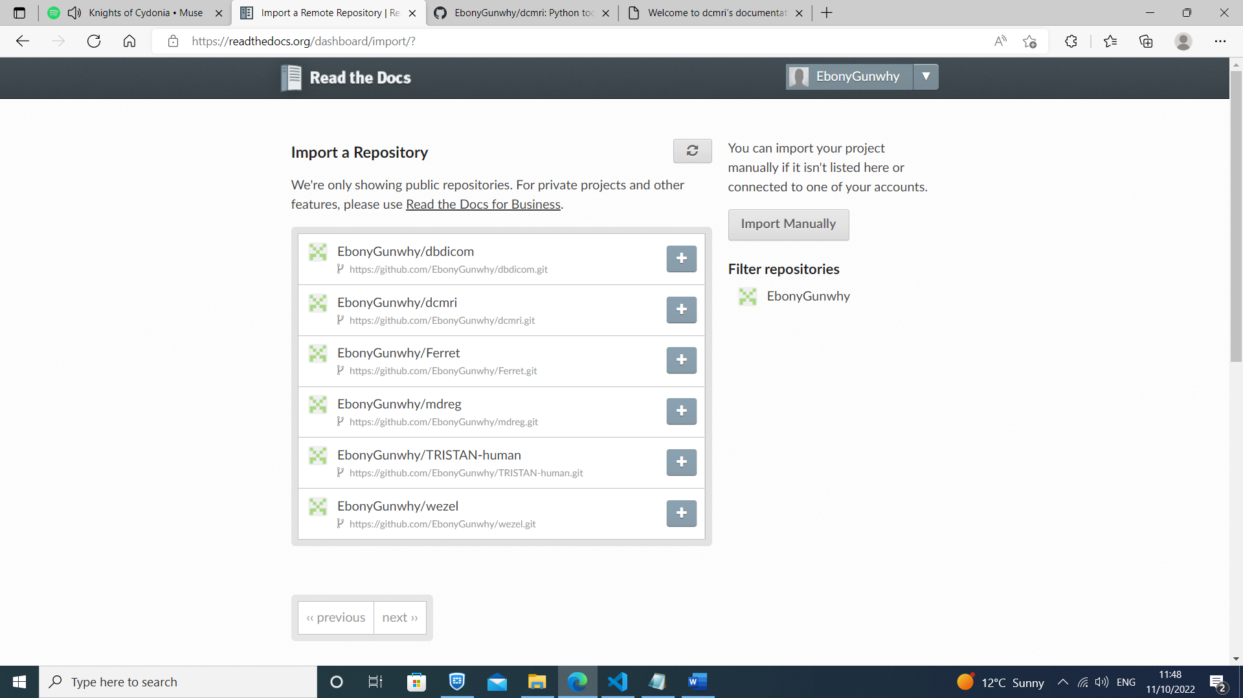

3. Input github repository name, url, and branch and click 'Next'

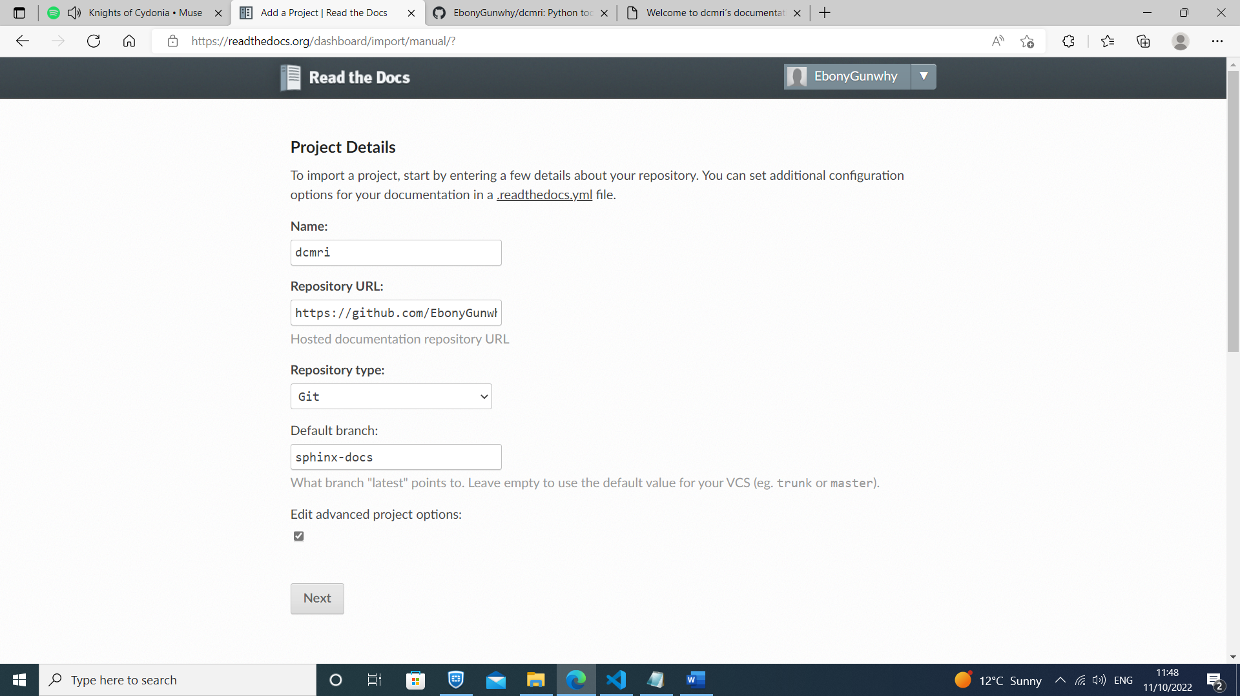

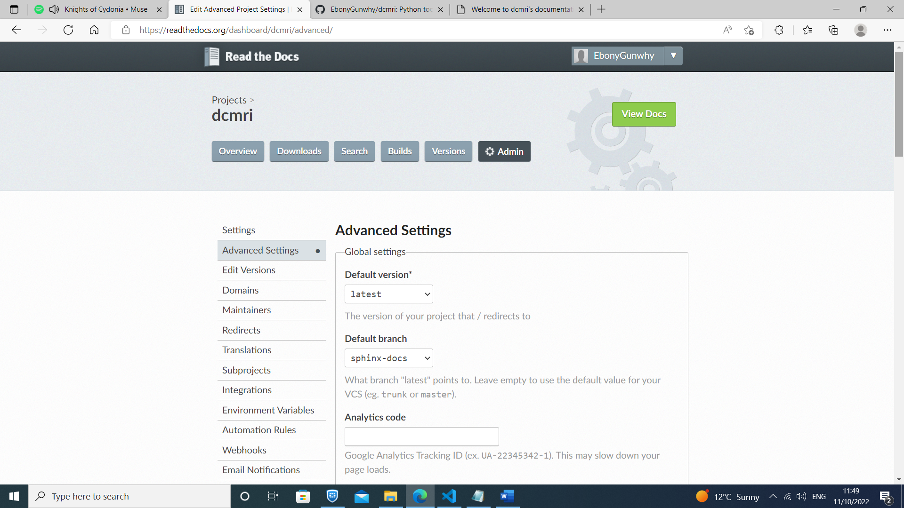4. Install in virtualenv

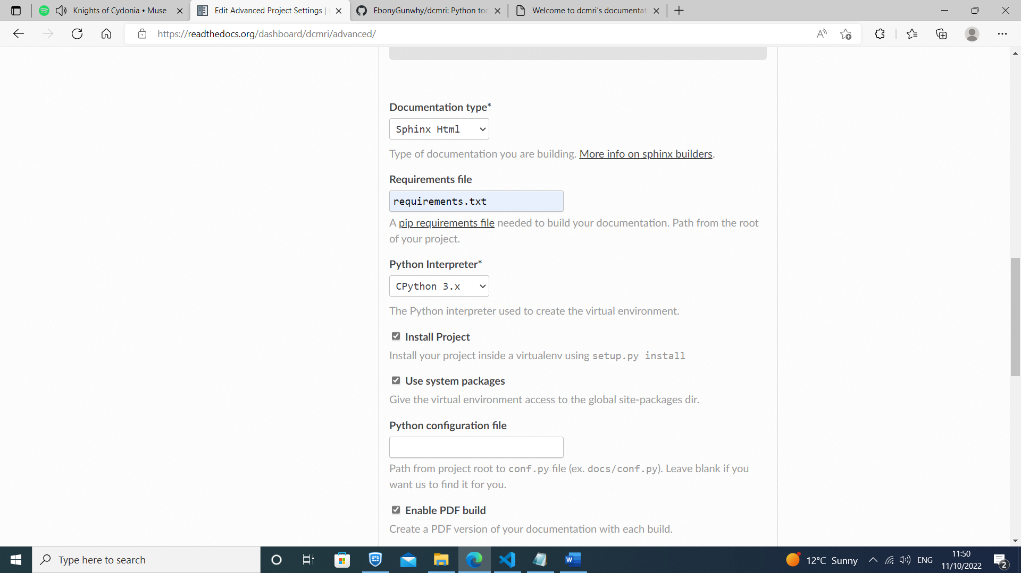

4. Click 'Build version' and wait for build to complete

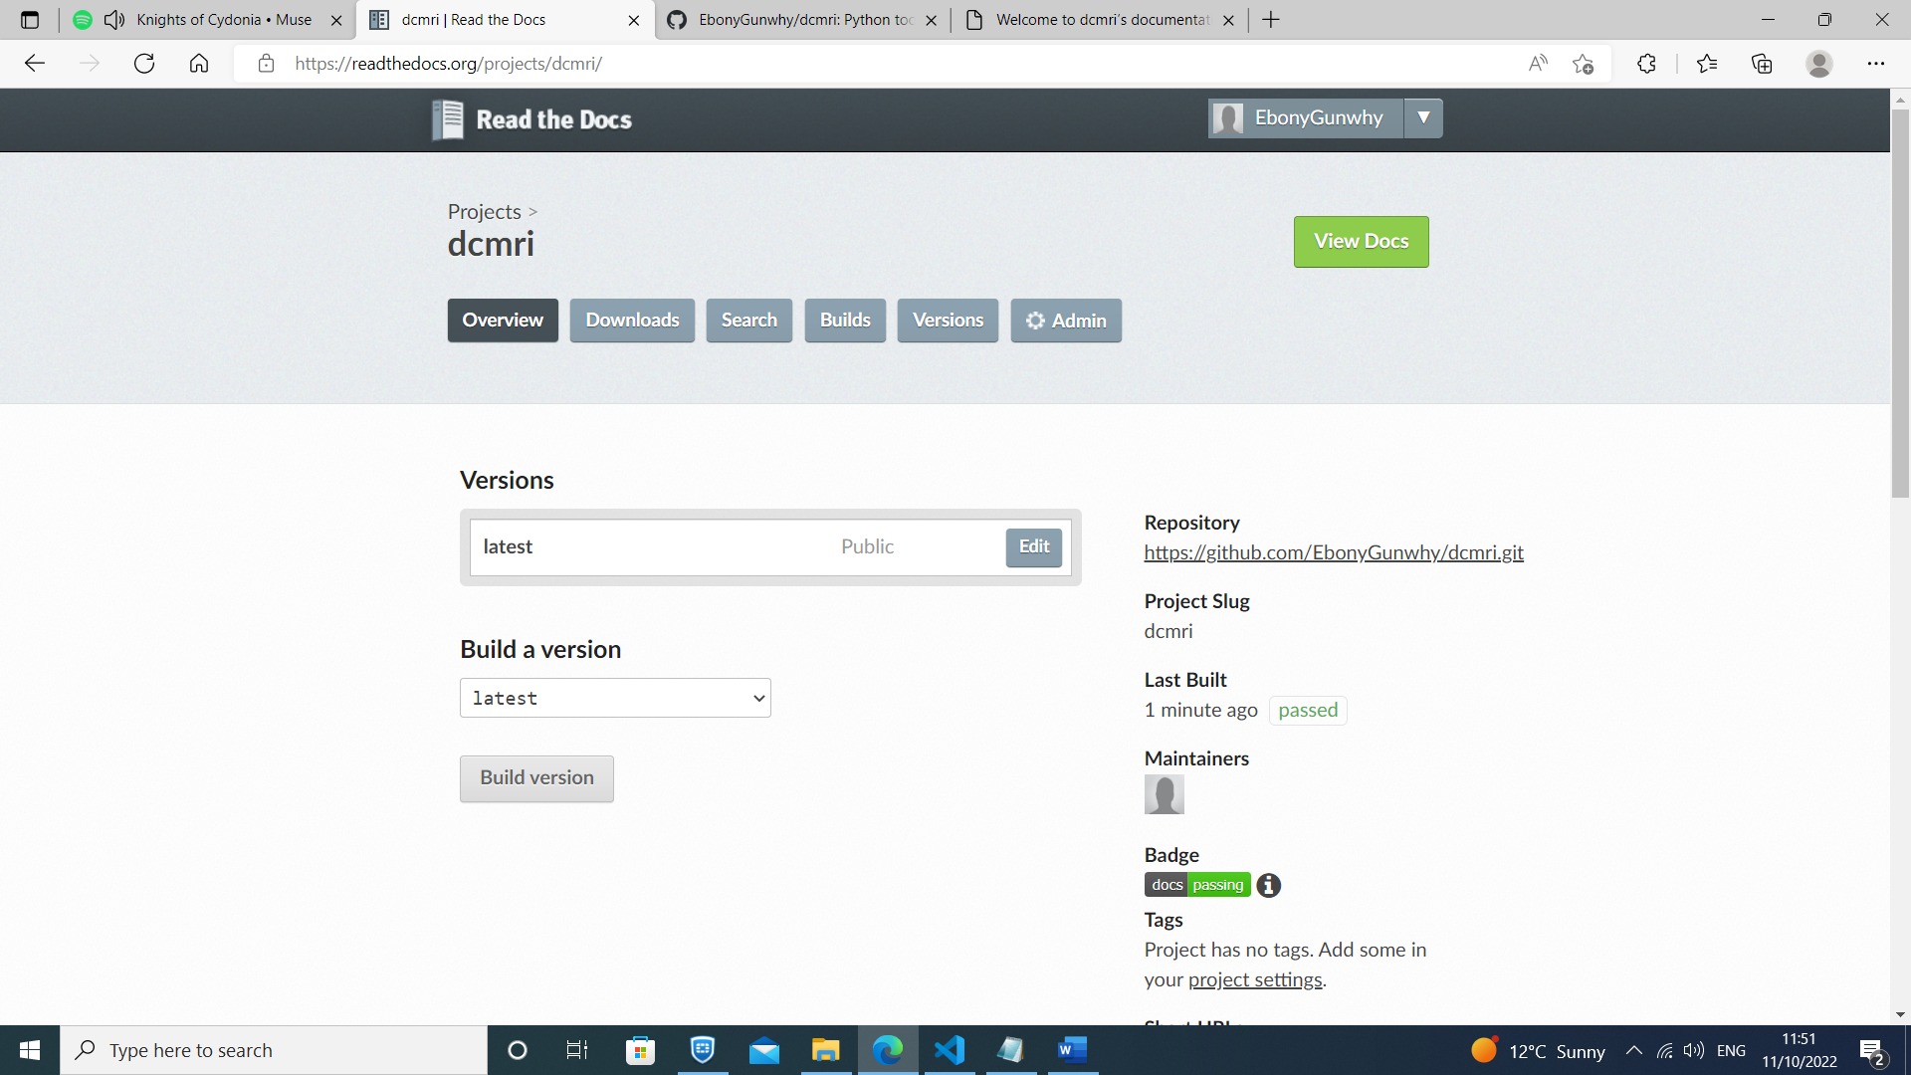

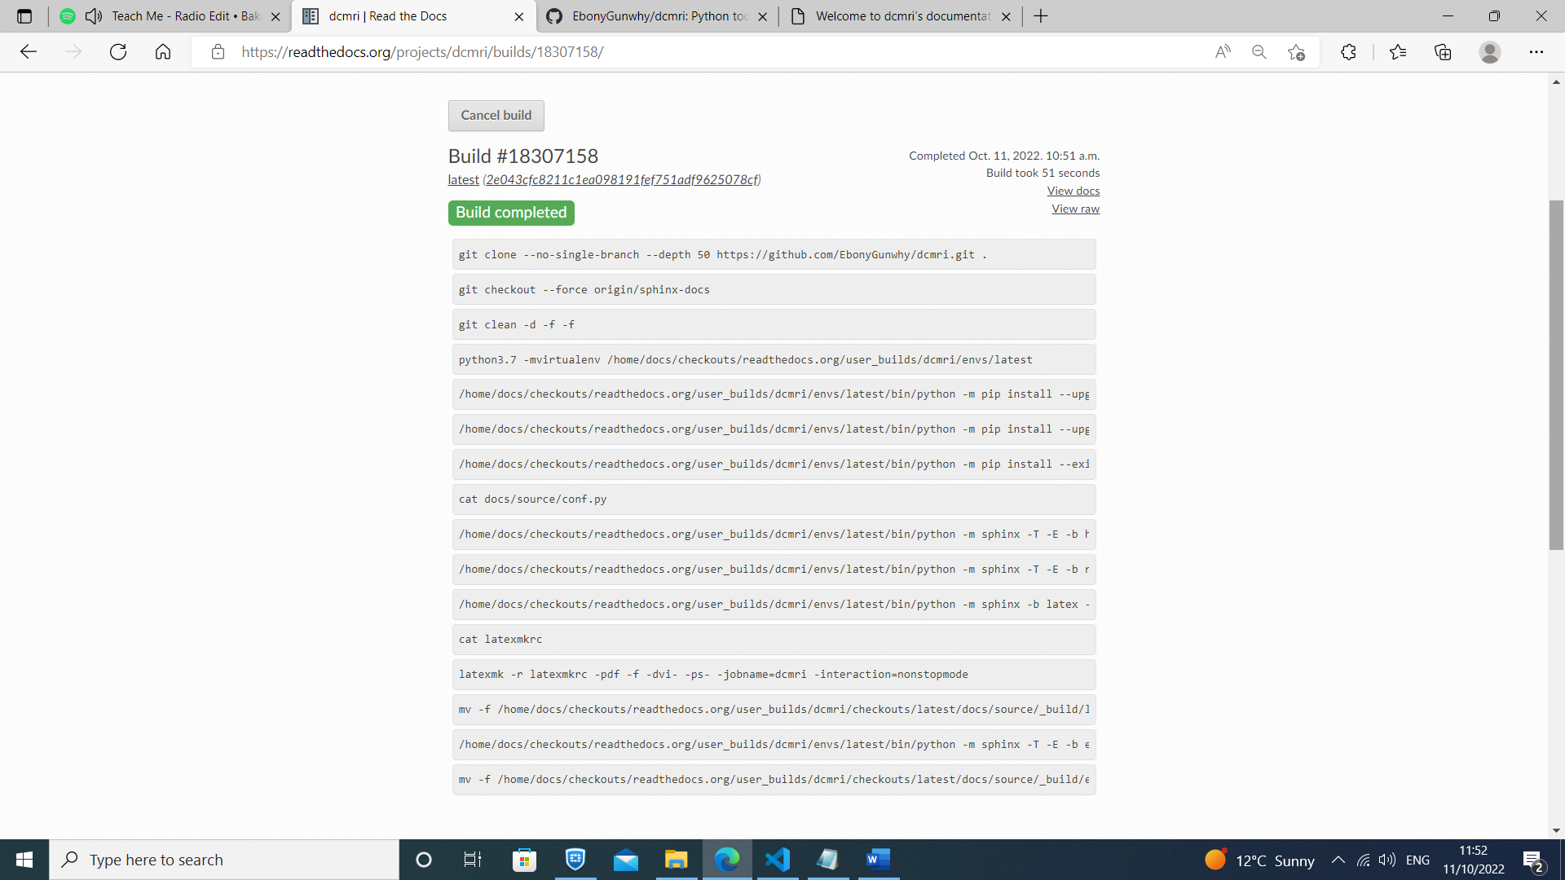

- Check RTDS build

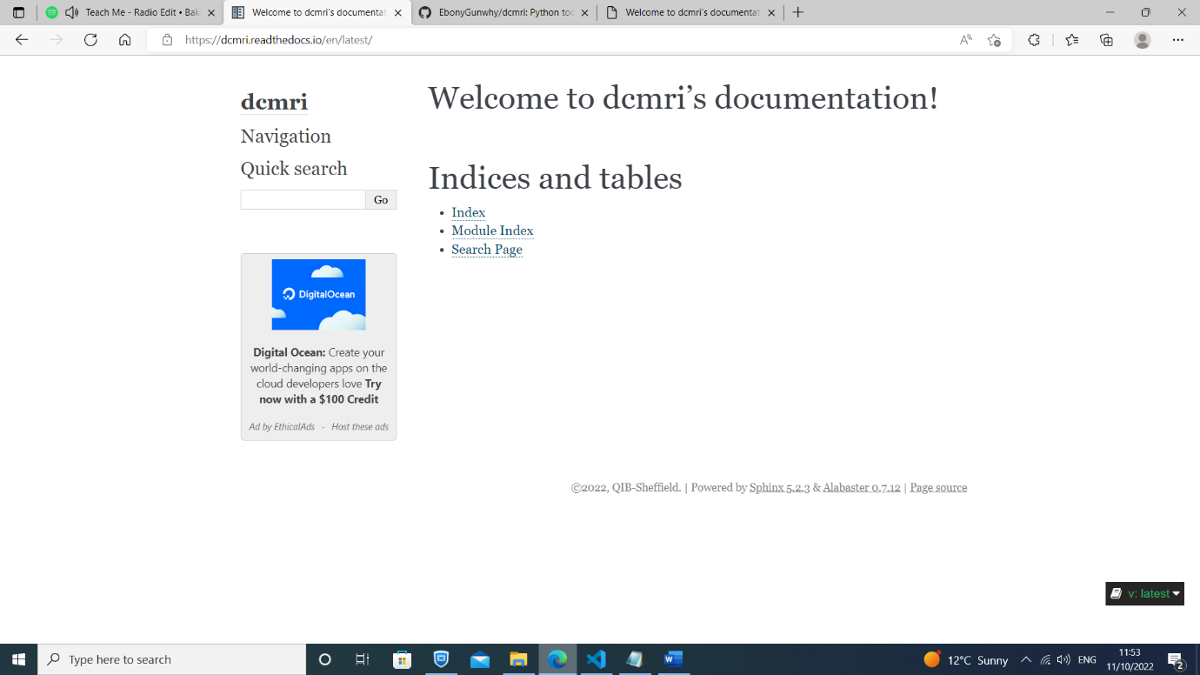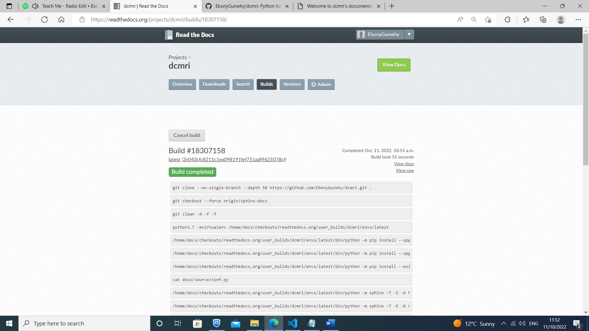

+++++++++++++++++++++++++++++++++++++++++++++++++++++++++++++++++++++++++++++++++

COMMIT #2. "Sphinx docs customisation via conf.py file"

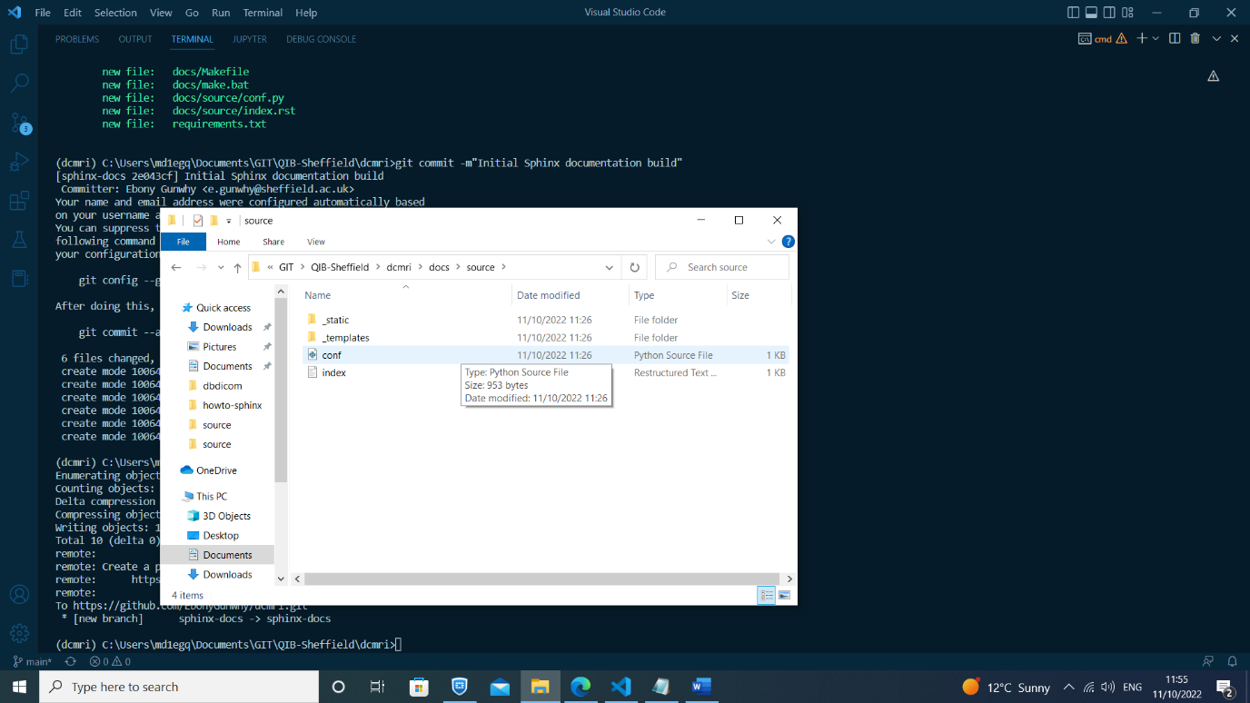

- Assign system path ('../../src')

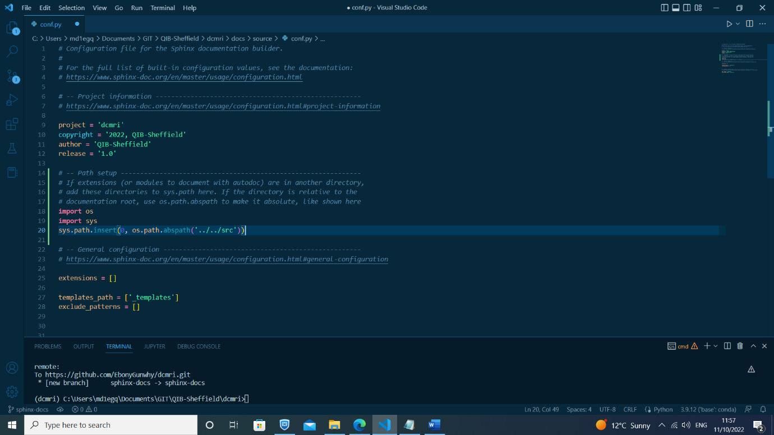

- Add sphinx_rtd_theme to requirements.txt file & pip install again

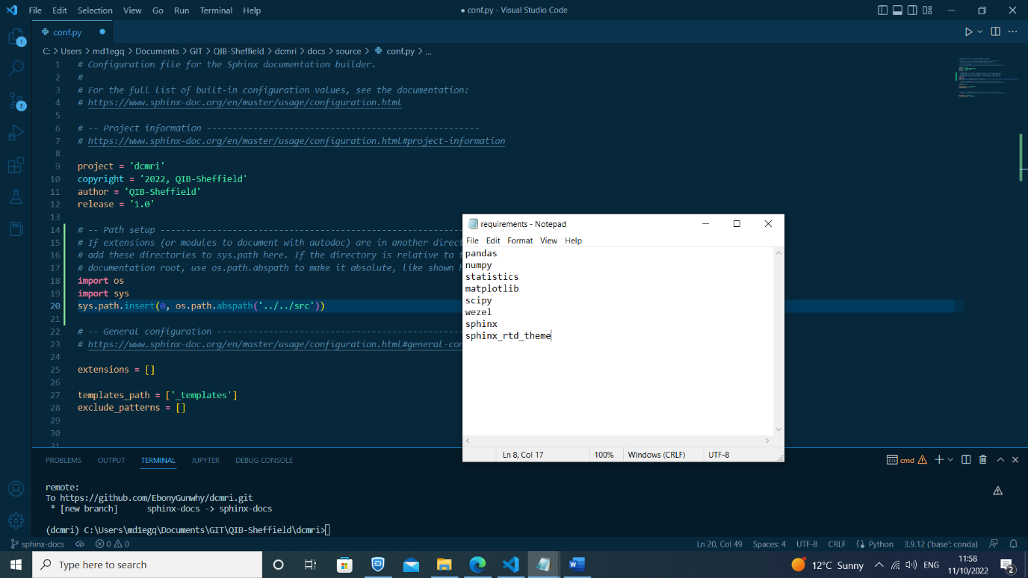

- Add extensions (autodoc, autosummary, napoleon, viewcode, intersphinx, sphinx_rtd_theme)

- Configure extensions (intersphinx_mapping, autosummary_generate)

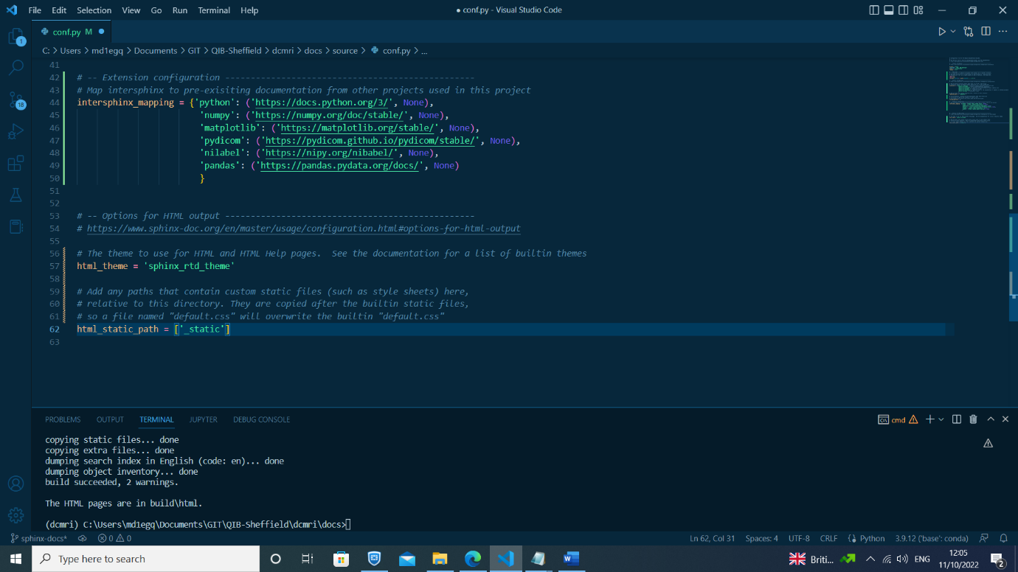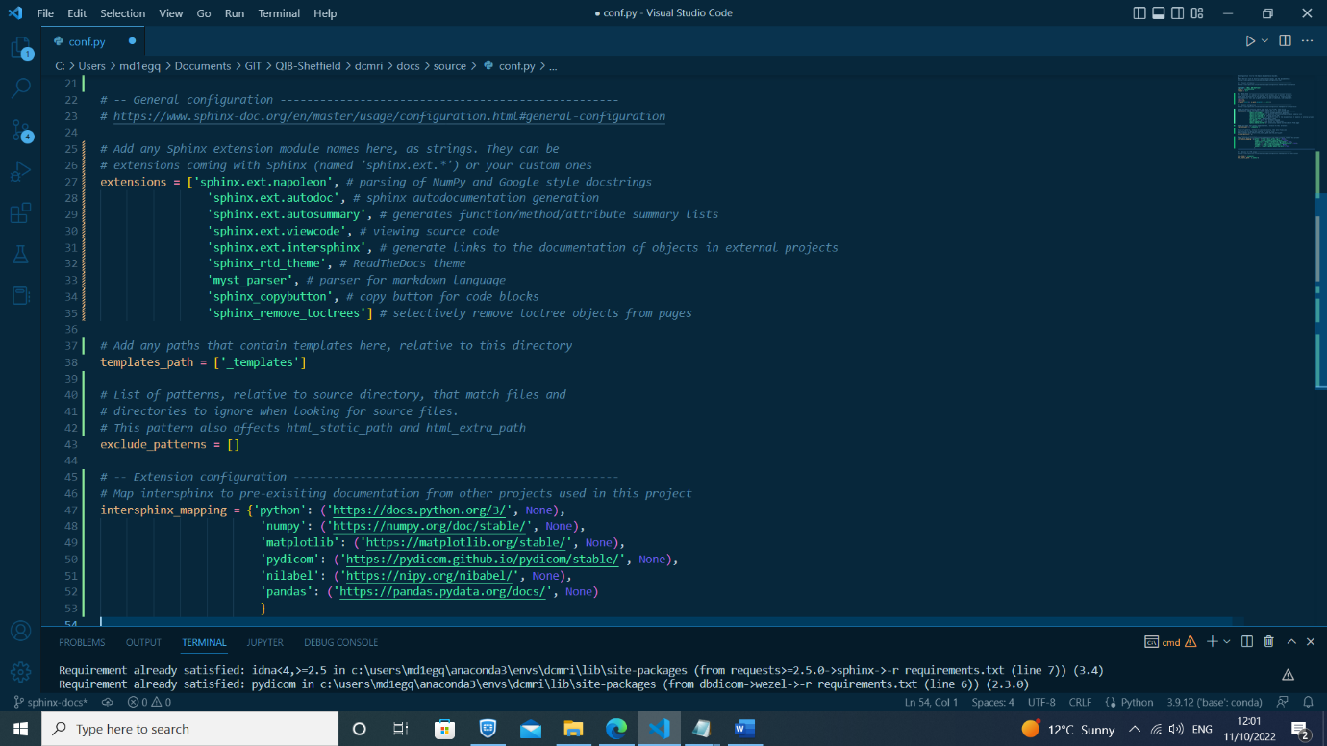

- Run sphinx apidoc from docs folder (sphinx-apidoc -f -o source ../src)

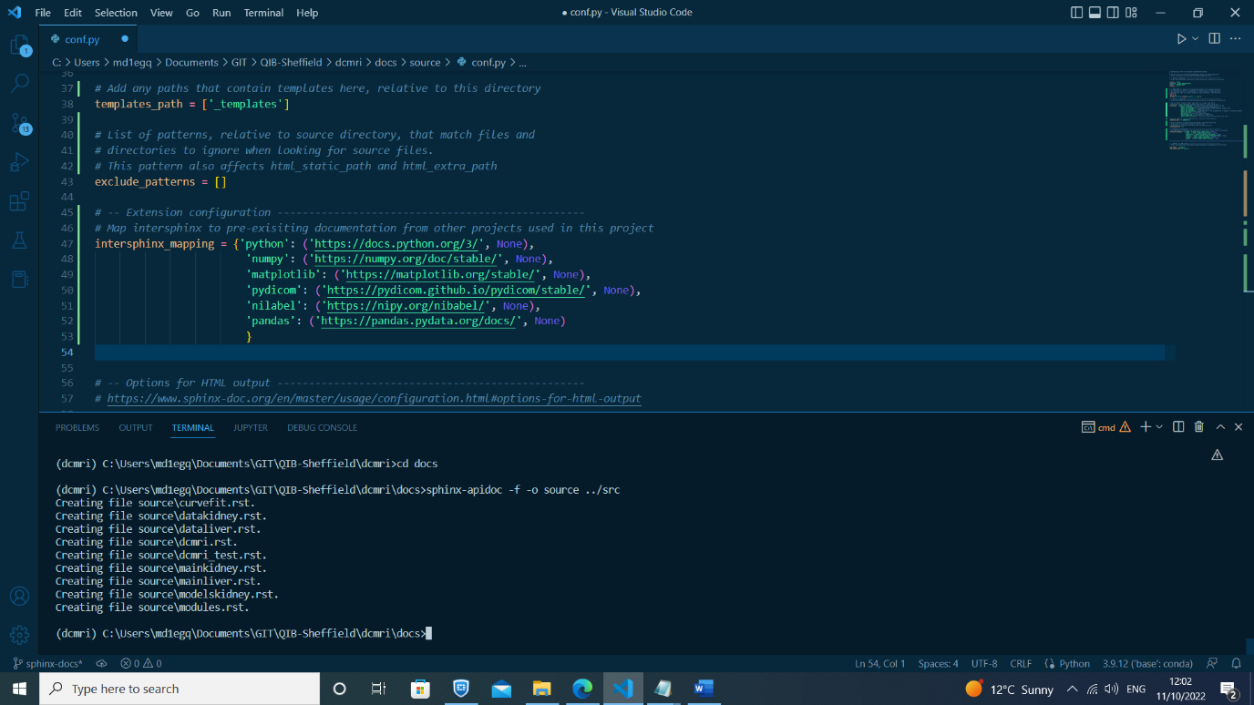

- Re-build html pages (make html)

- Check sphinx build

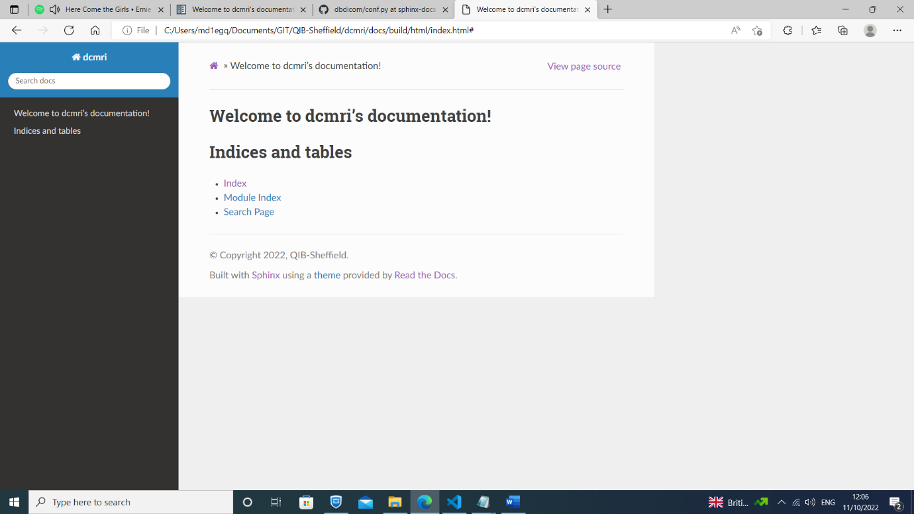

- Push to Github (from main folder tree)

- Sync with RTDs

- Check RTDs build

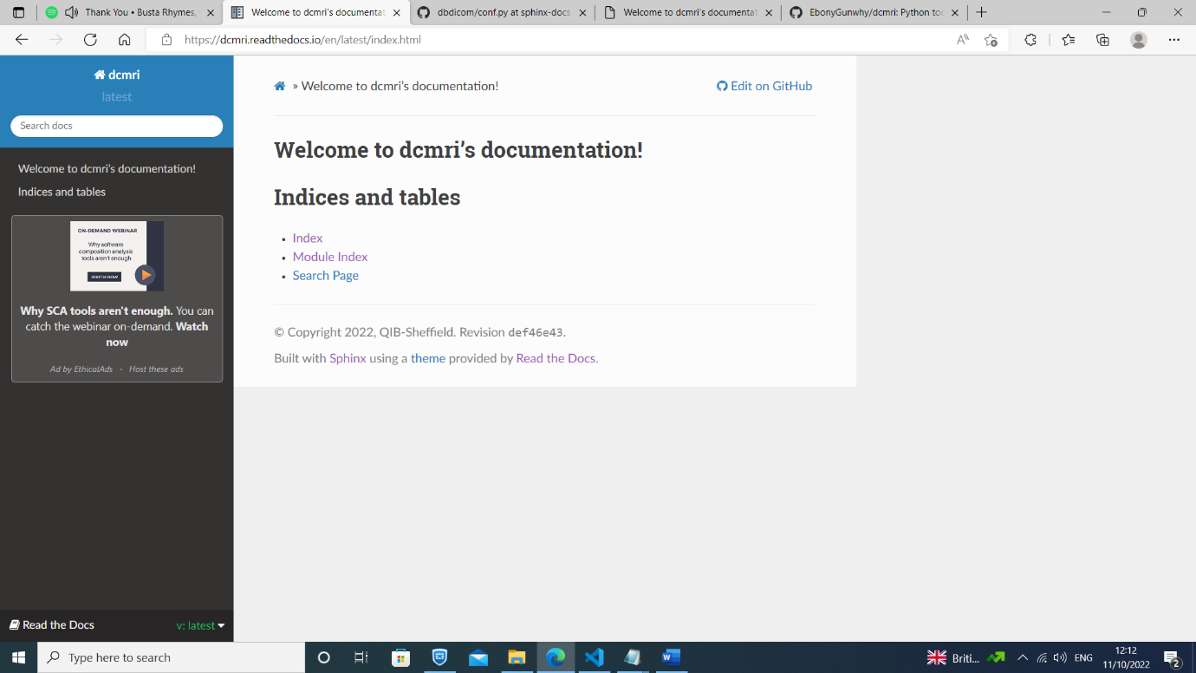

+++++++++++++++++++++++++++++++++++++++++++++++++++++++++++++++++++++++++++++++++

COMMIT #3. "Add contents for module API documentation"

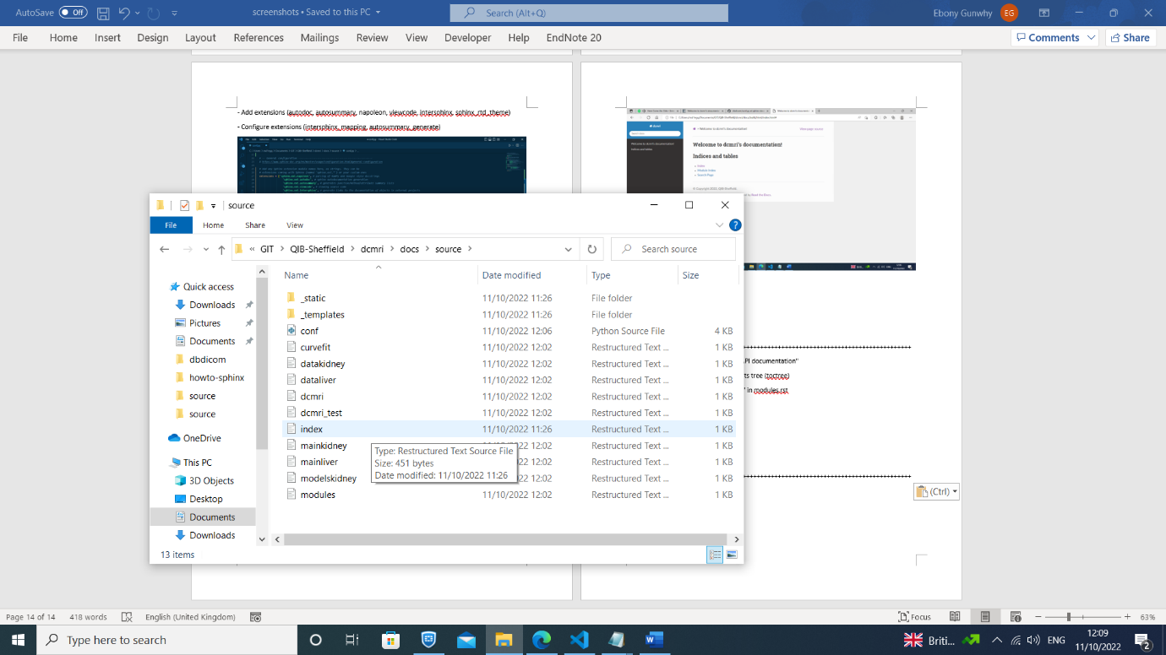- Add API doc modules to table of contents tree (toctree)

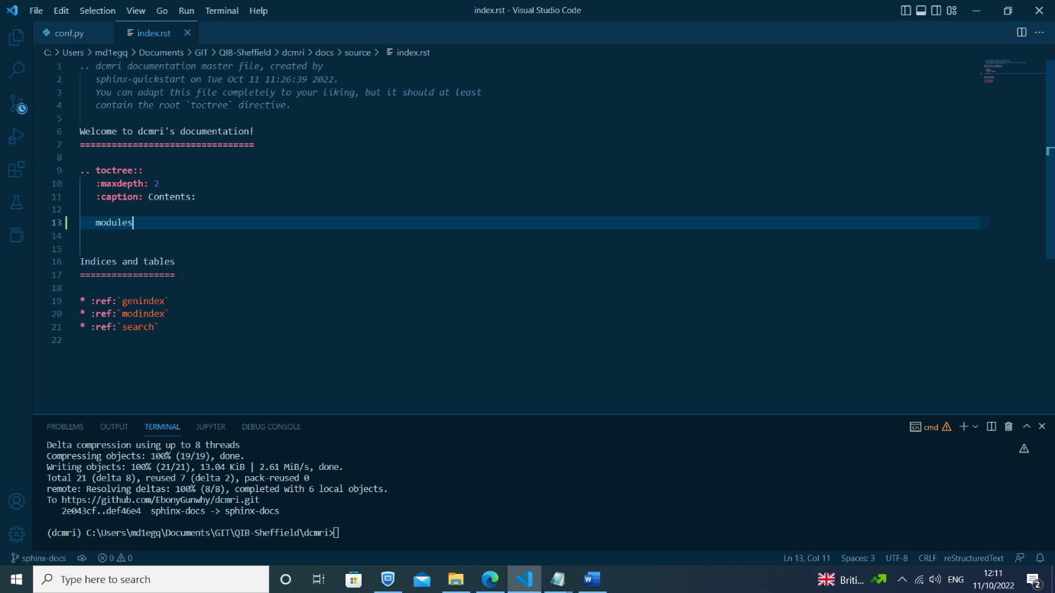

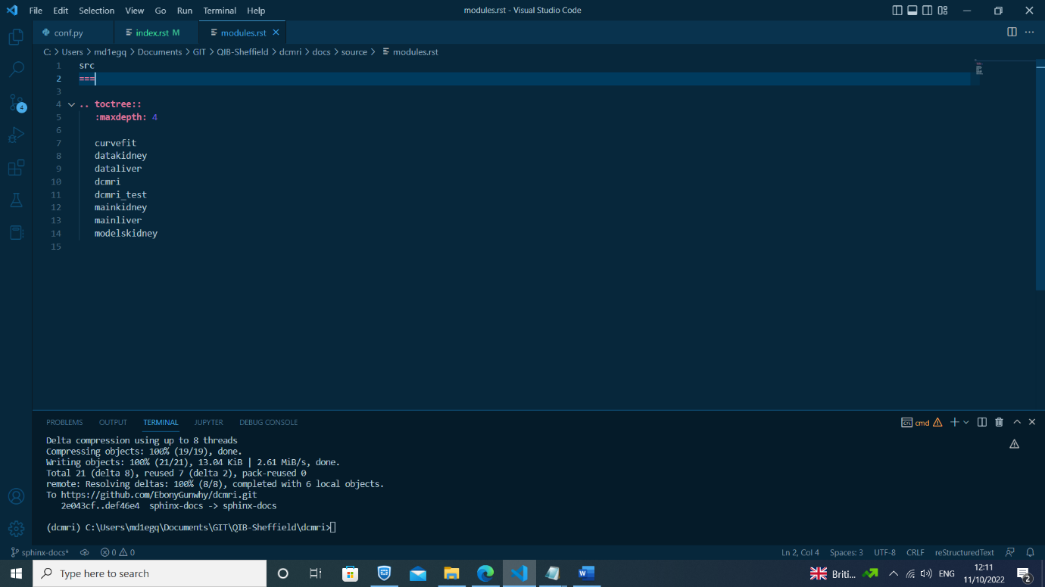- Change title 'src' to 'API documentation' in modules.rst

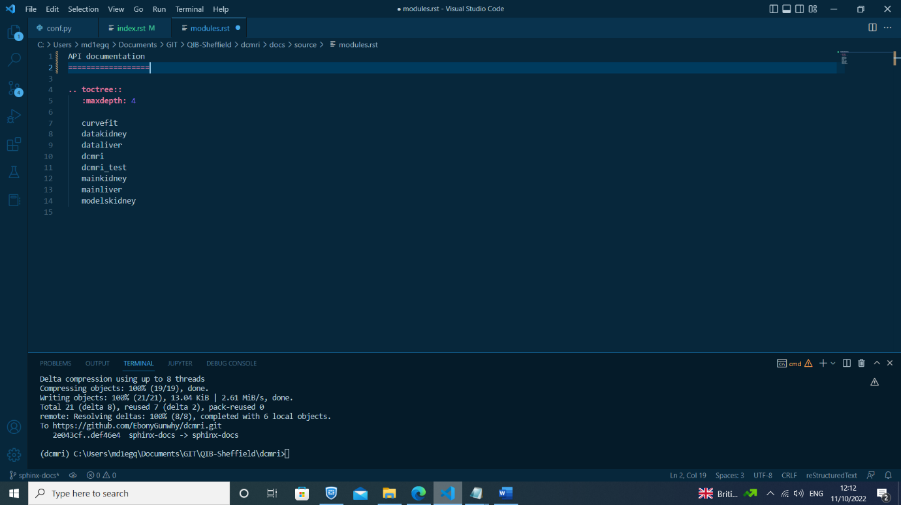

- Re-build html pages (make html)

- Check sphinx build

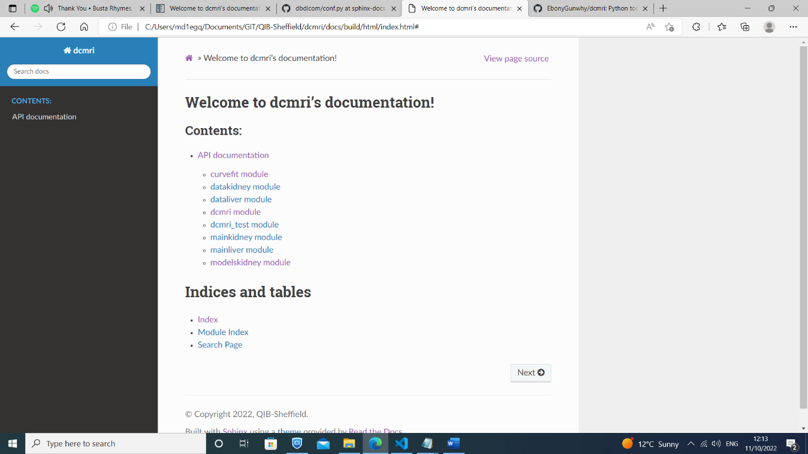

- Push to Github

- Sync with RTDs

- Check RTDs build

+++++++++++++++++++++++++++++++++++++++++++++++++++++++++++++++++++++++++++++++++

COMMIT #4. "Link to README in sphinx docs & add parser for markdown (.md) files"

- Add myst-parser to requirements.txt file & pip install again

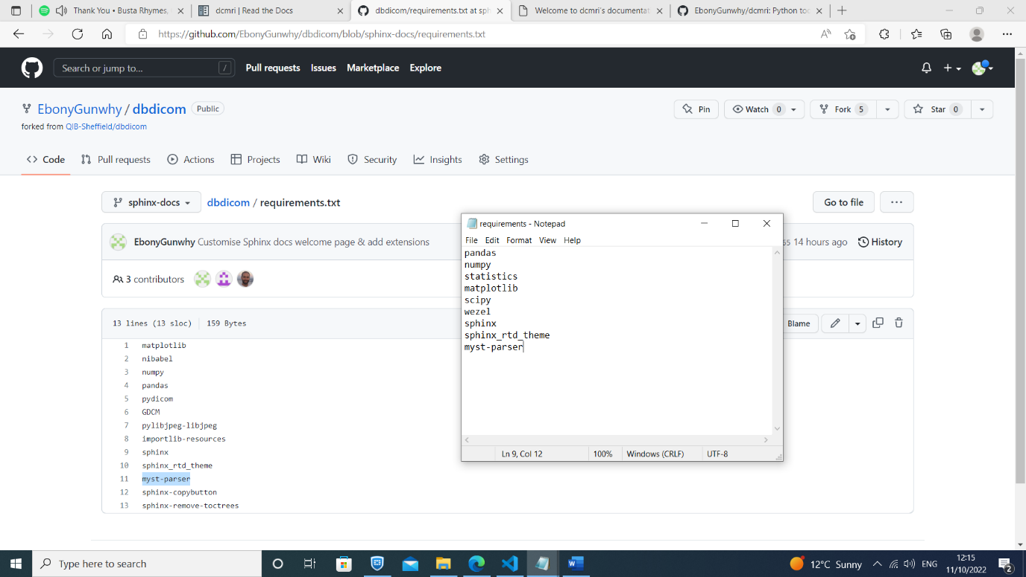- Add myst_parser extension to conf.py file

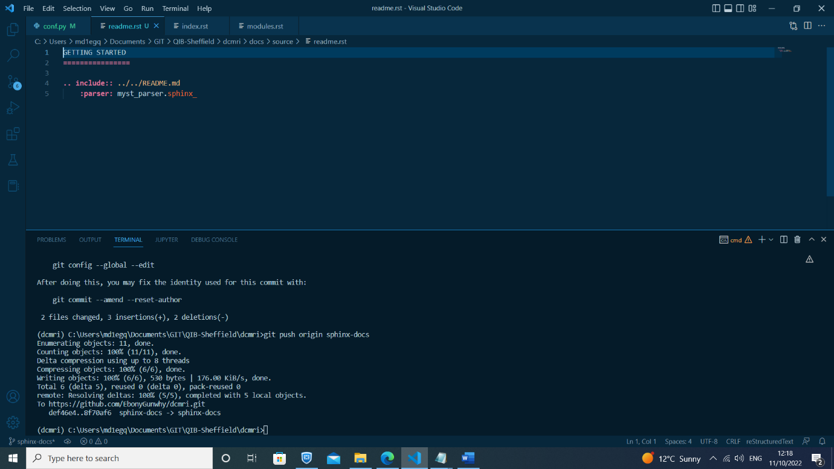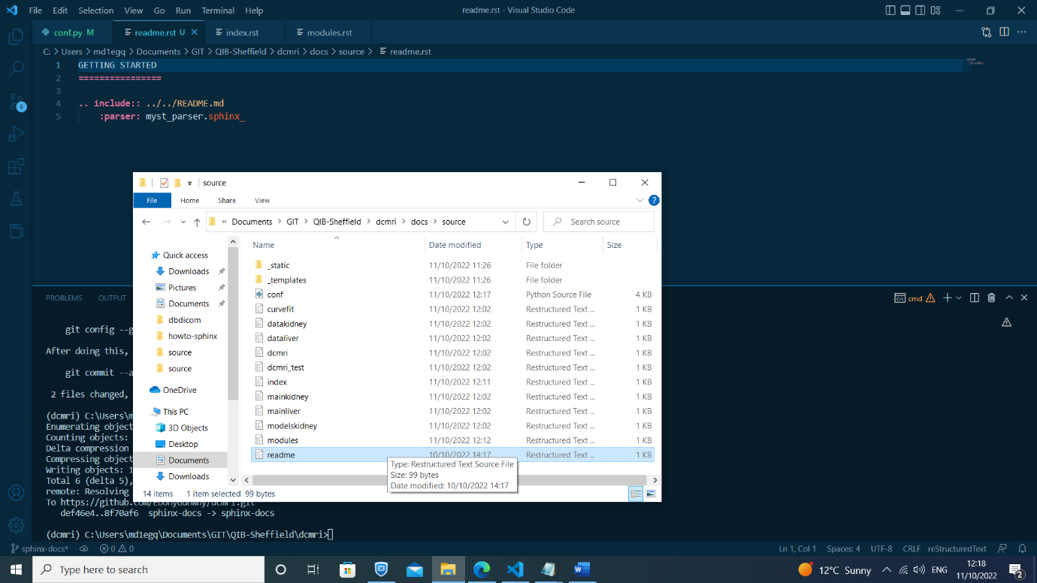- Create readme.rst file linking to README.md in dbdicom parent folder

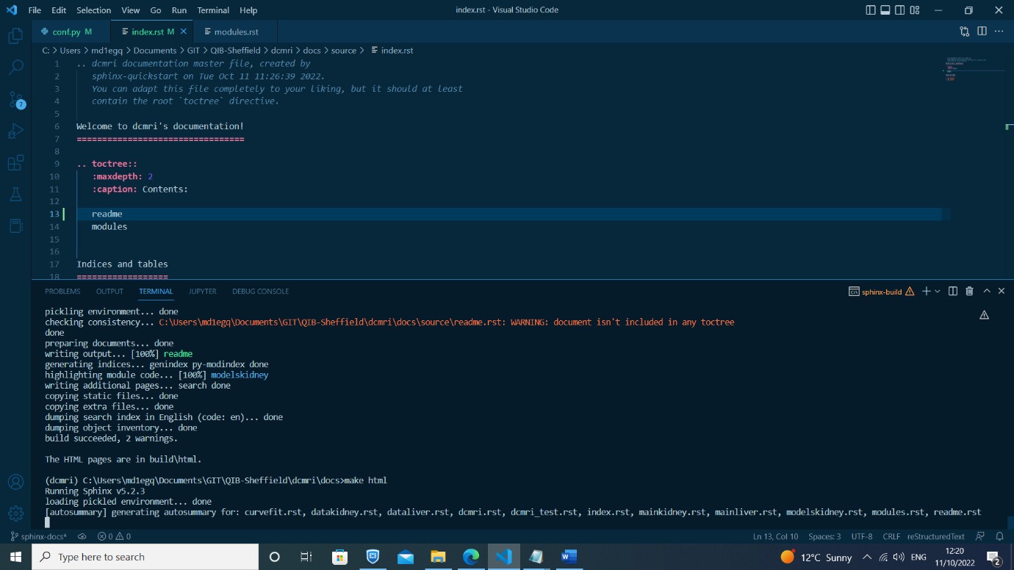

- Enable .md suffix in conf.py file

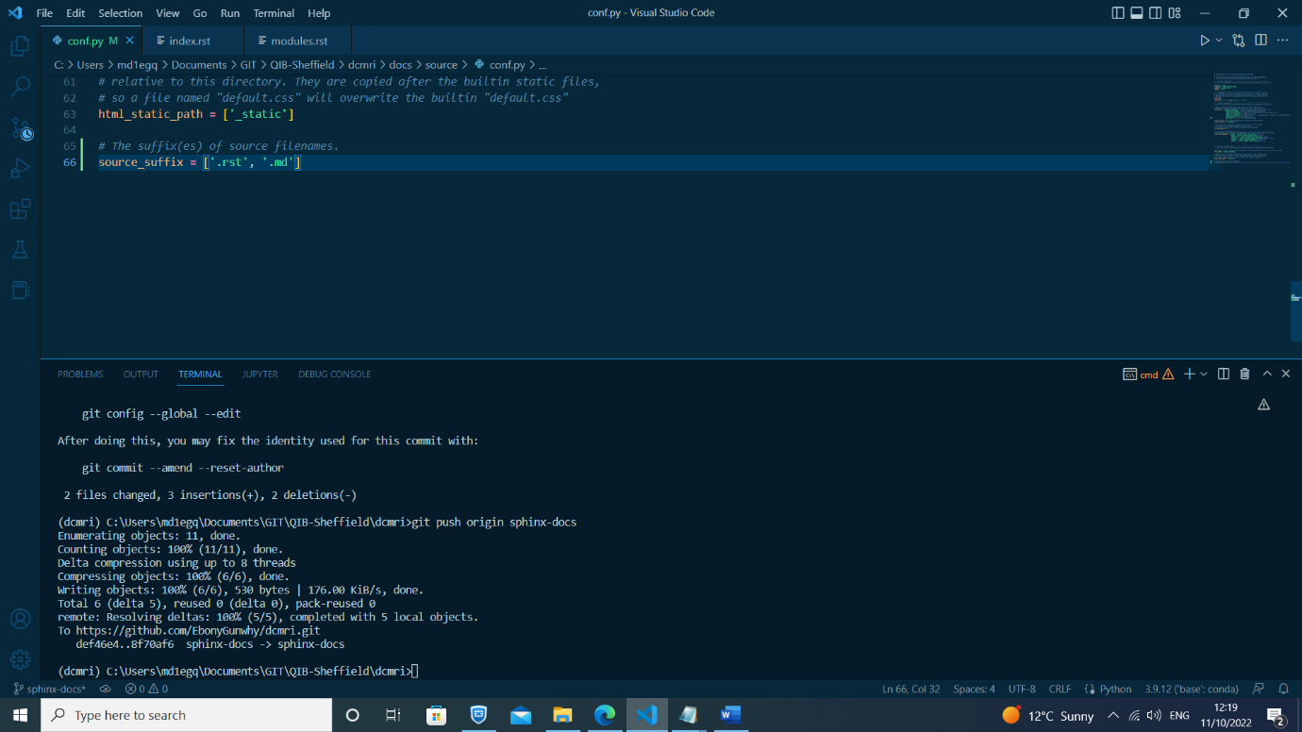

- Re-build html pages (make html)

- Check sphinx build

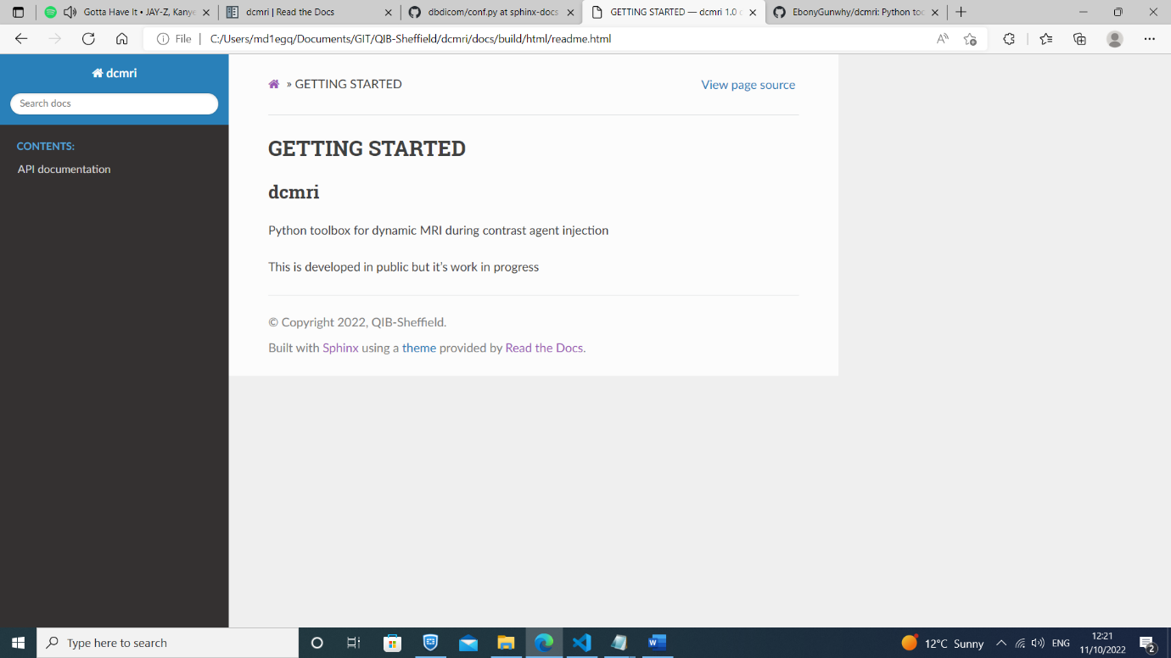

- Push to Github

- Sync with RTDs

- Check RTDs build

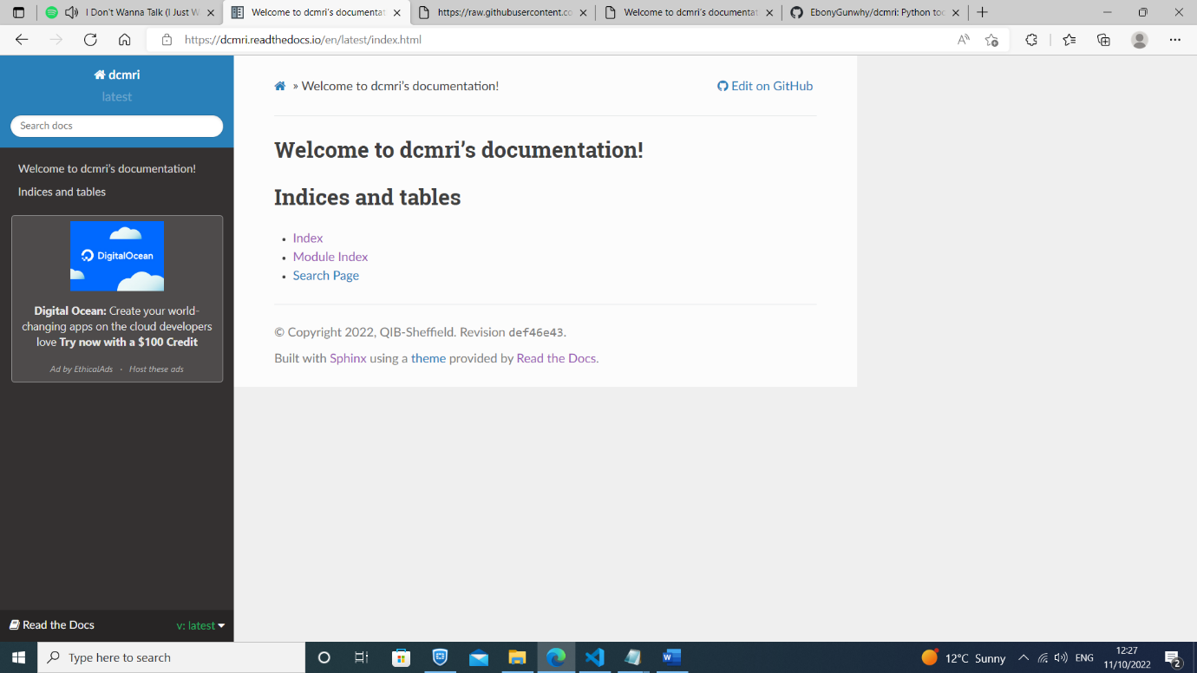

+++++++++++++++++++++++++++++++++++++++++++++++++++++++++++++++++++++++++++++++++

COMMIT #5 ”[Customise Sphinx docs welcome page & add extensions](https://github.com/EbonyGunwhy/dbdicom/commit/c67fd652c3b01361e49a90e8f5f18dfc54f715b9)”

- Welcome page:

- Insert text about dbdicom

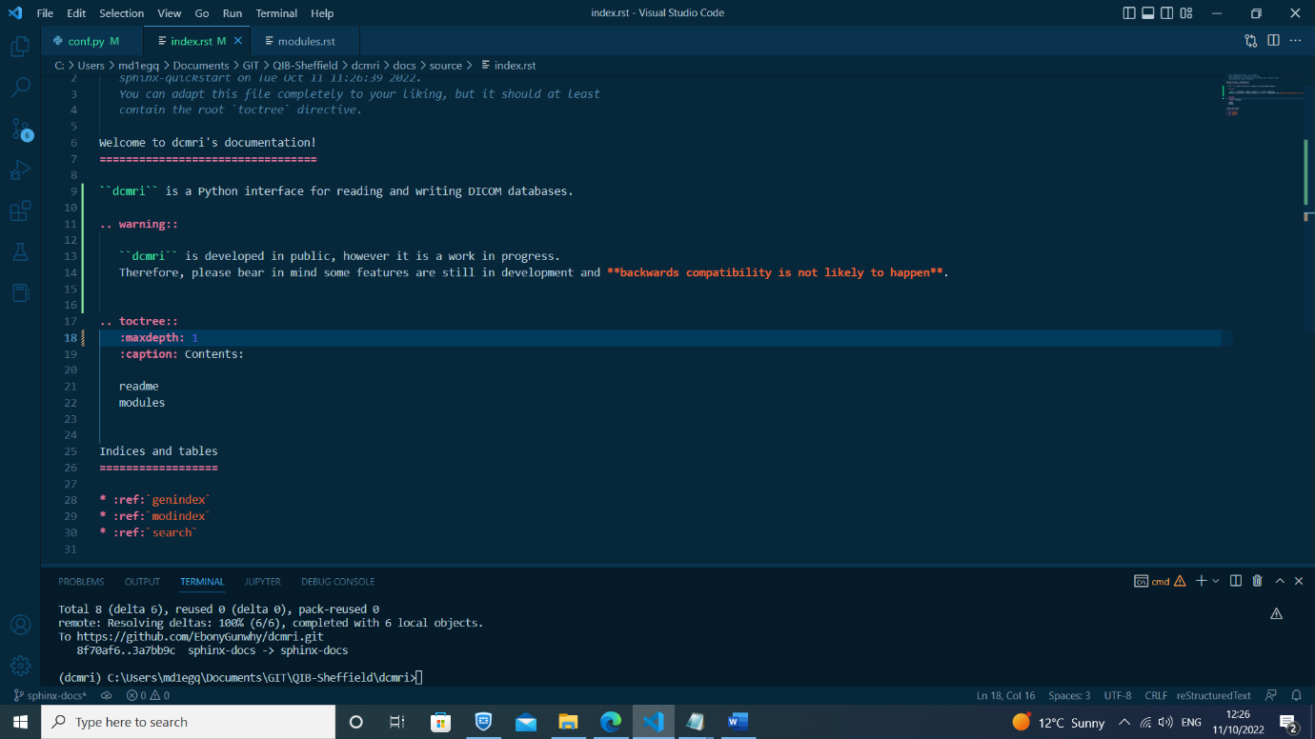 - Add warning box for 'work in progress'

- Add Sheffield logo to sidebar

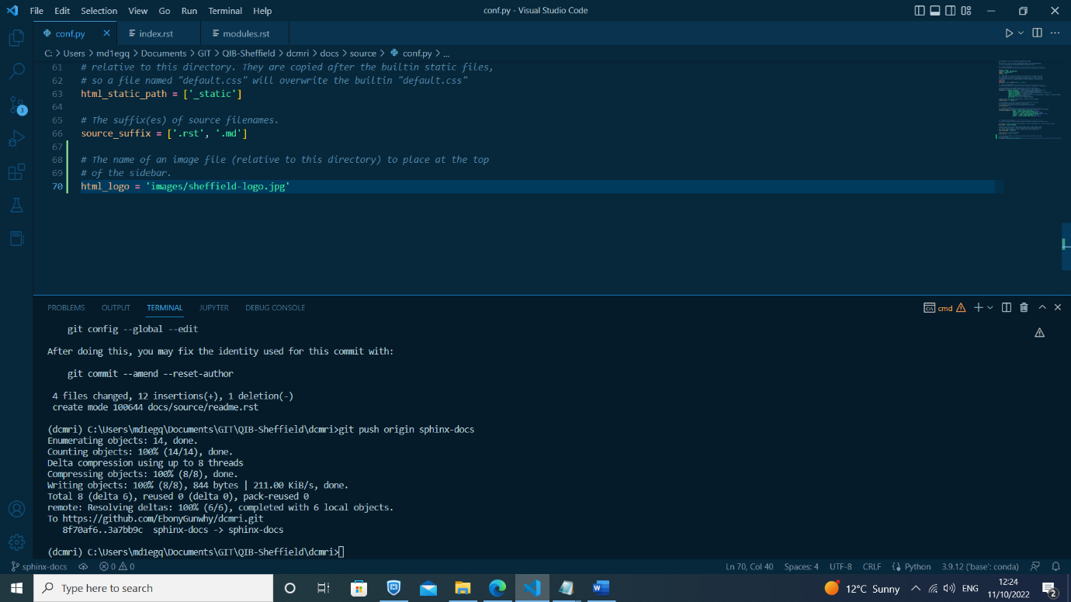

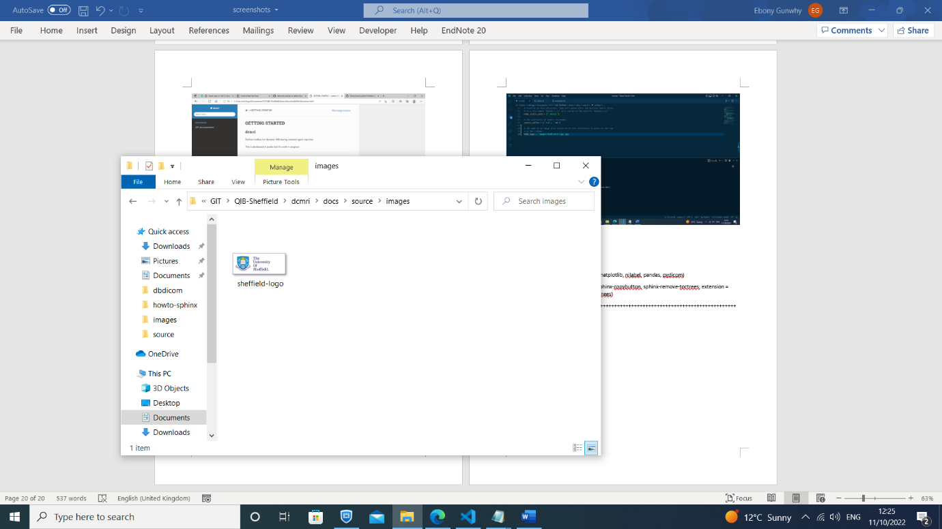

- conf.py:

- update intersphinx mappings (matplotlib, nilabel, pandas, pydicom)

- update extensions (pip install sphinx-copybutton, sphinx-remove-toctrees; extension = sphinx_copybutton, sphinx_remove_toctrees)



